**ANALYSIS OF PHASE 2**

**2.1 Analysis of Literacy rate vs Total crimes**.

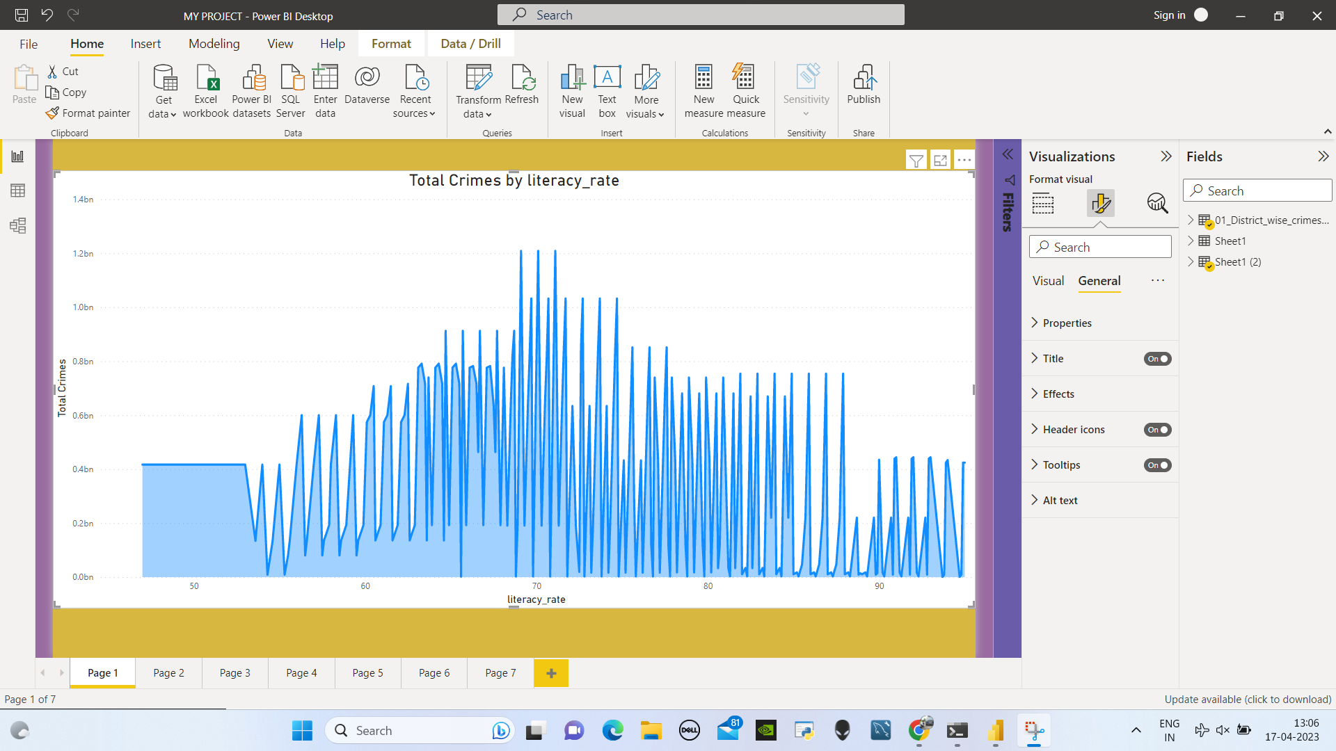

As the literacy rate increases, we can observe a corresponding decrease in crime rates. However, the relationship between the two is not necessarily linear. Initially, as the literacy rate rises from 0% to 70%, there is a decrease in crime. Beyond this threshold, the crime rate actually increases until the literacy rate reaches 85%, at which point the crime rate begins to decrease once more.

**2.2 Analysis of the type of crime vs each state vs Literacy rate*.***

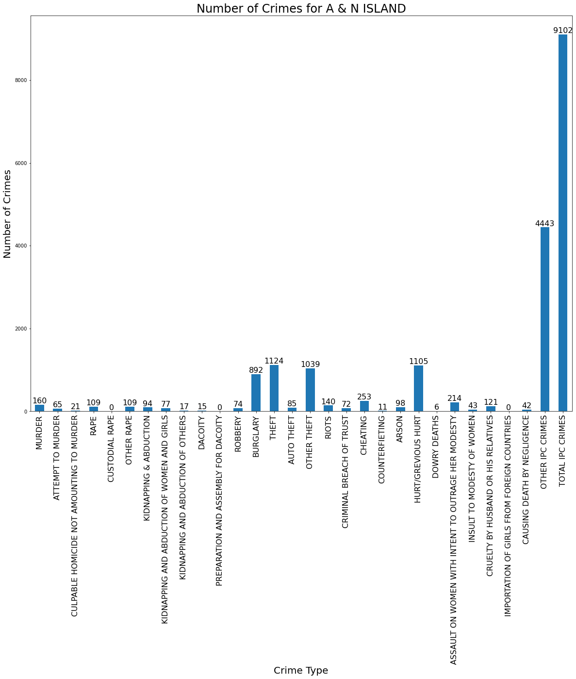

From Above Graph We Observe That In A & N Island The 'Burglary', 'Theft','Hurt/Grevious Hurt','Other Ipc Crimes', 'Total Ipc Crimes' Are More In This State.

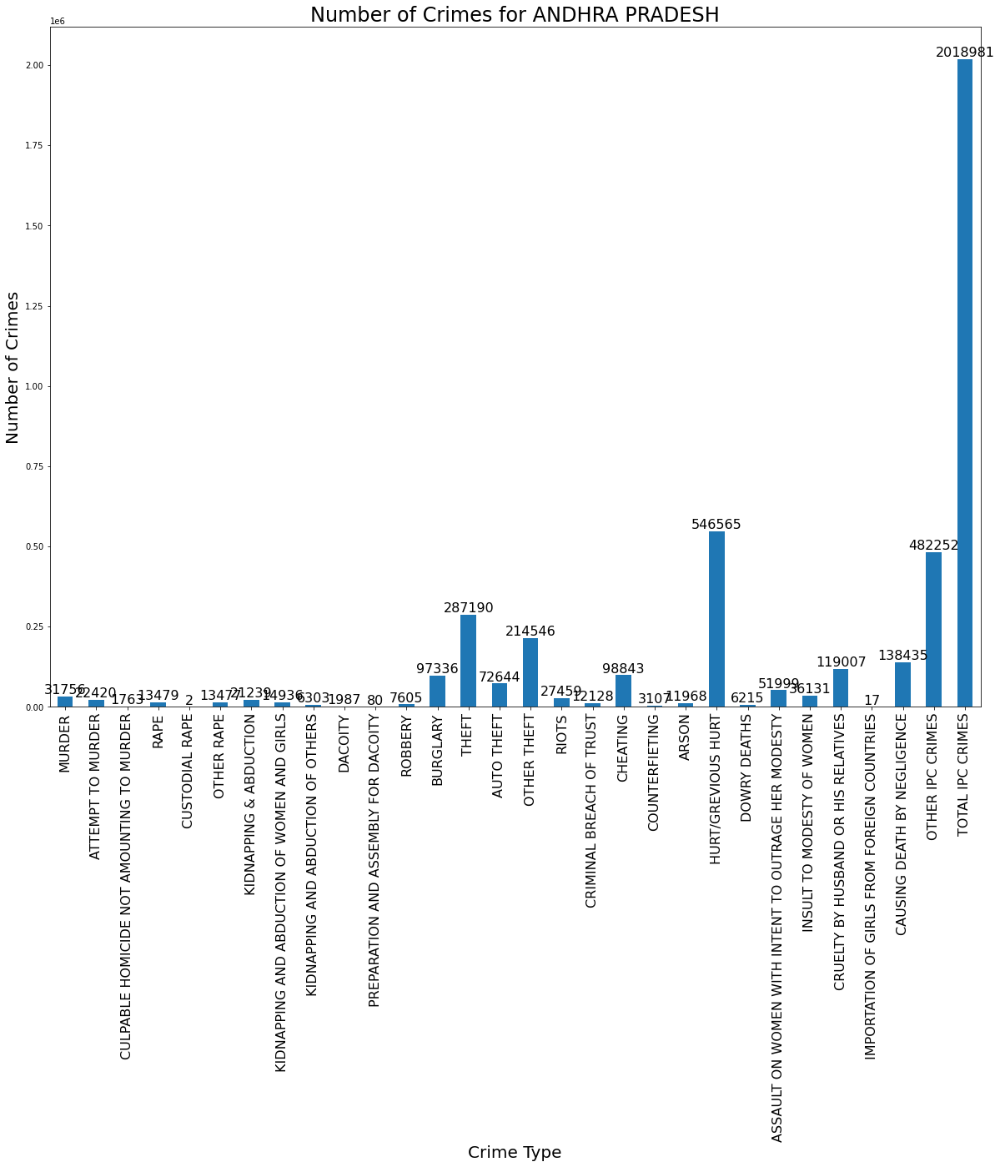

# From Above Graph We Observe That In Andhra Pradesh The 'Burglary', 'Theft','Hurt/Grevious Hurt','Other Ipc Crimes', 'Total Ipc Crimes' ,Cruelty By Husband Or His Relatives' , 'Causing Death By Negligence' Are More In This State.

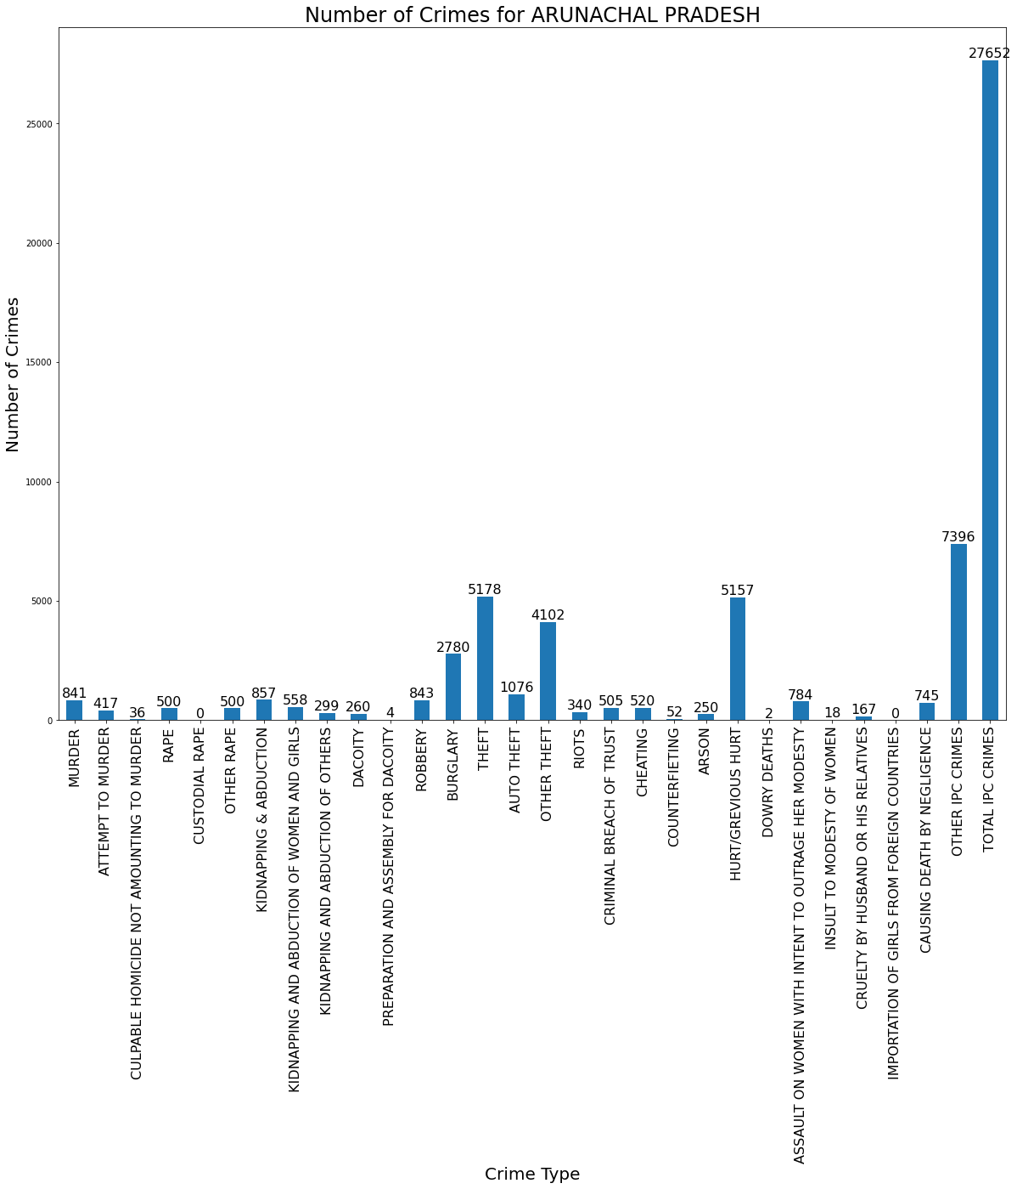

# From Above Graph We Observe That In Arunachal Pradesh The 'Burglary', 'Theft','Hurt/Grevious Hurt','Other Ipc Crimes', 'Total Ipc Crimes' , Are More In This State

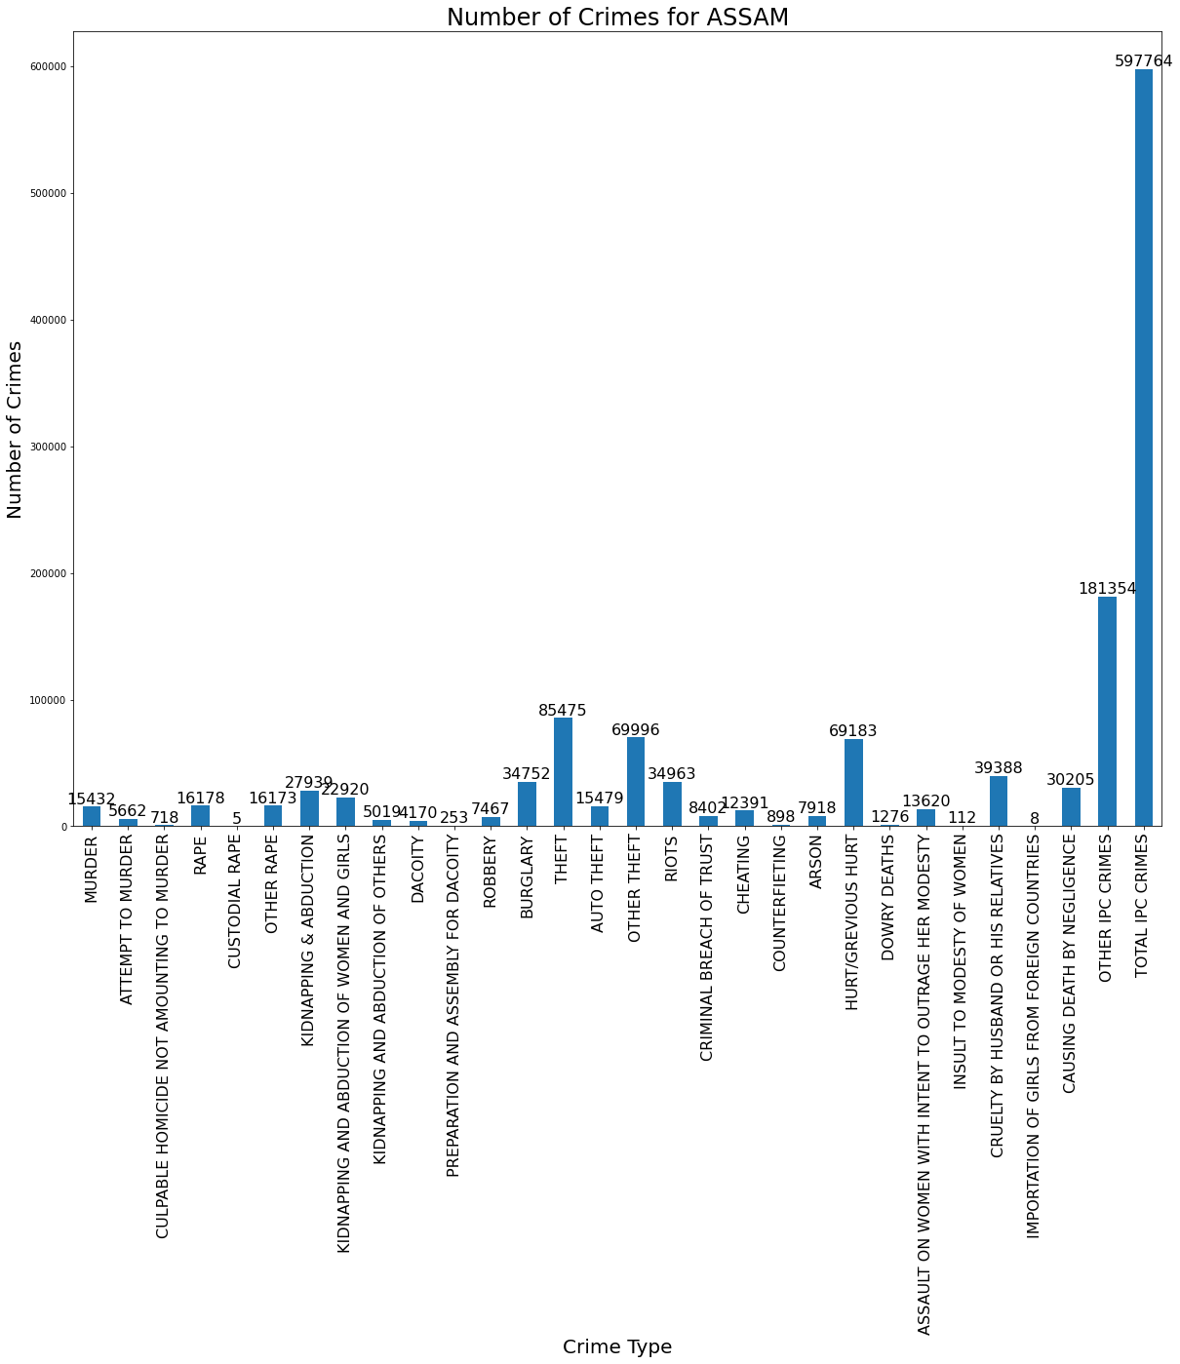

# From Above Graph We Observe That In Assam The 'Burglary', 'Theft','Hurt/Grevious Hurt','Other Ipc Crimes', 'Total Ipc Crimes' ,Cruelty By Husband Or His Relatives' , 'Causing Death By Negligence' Are More In This State.

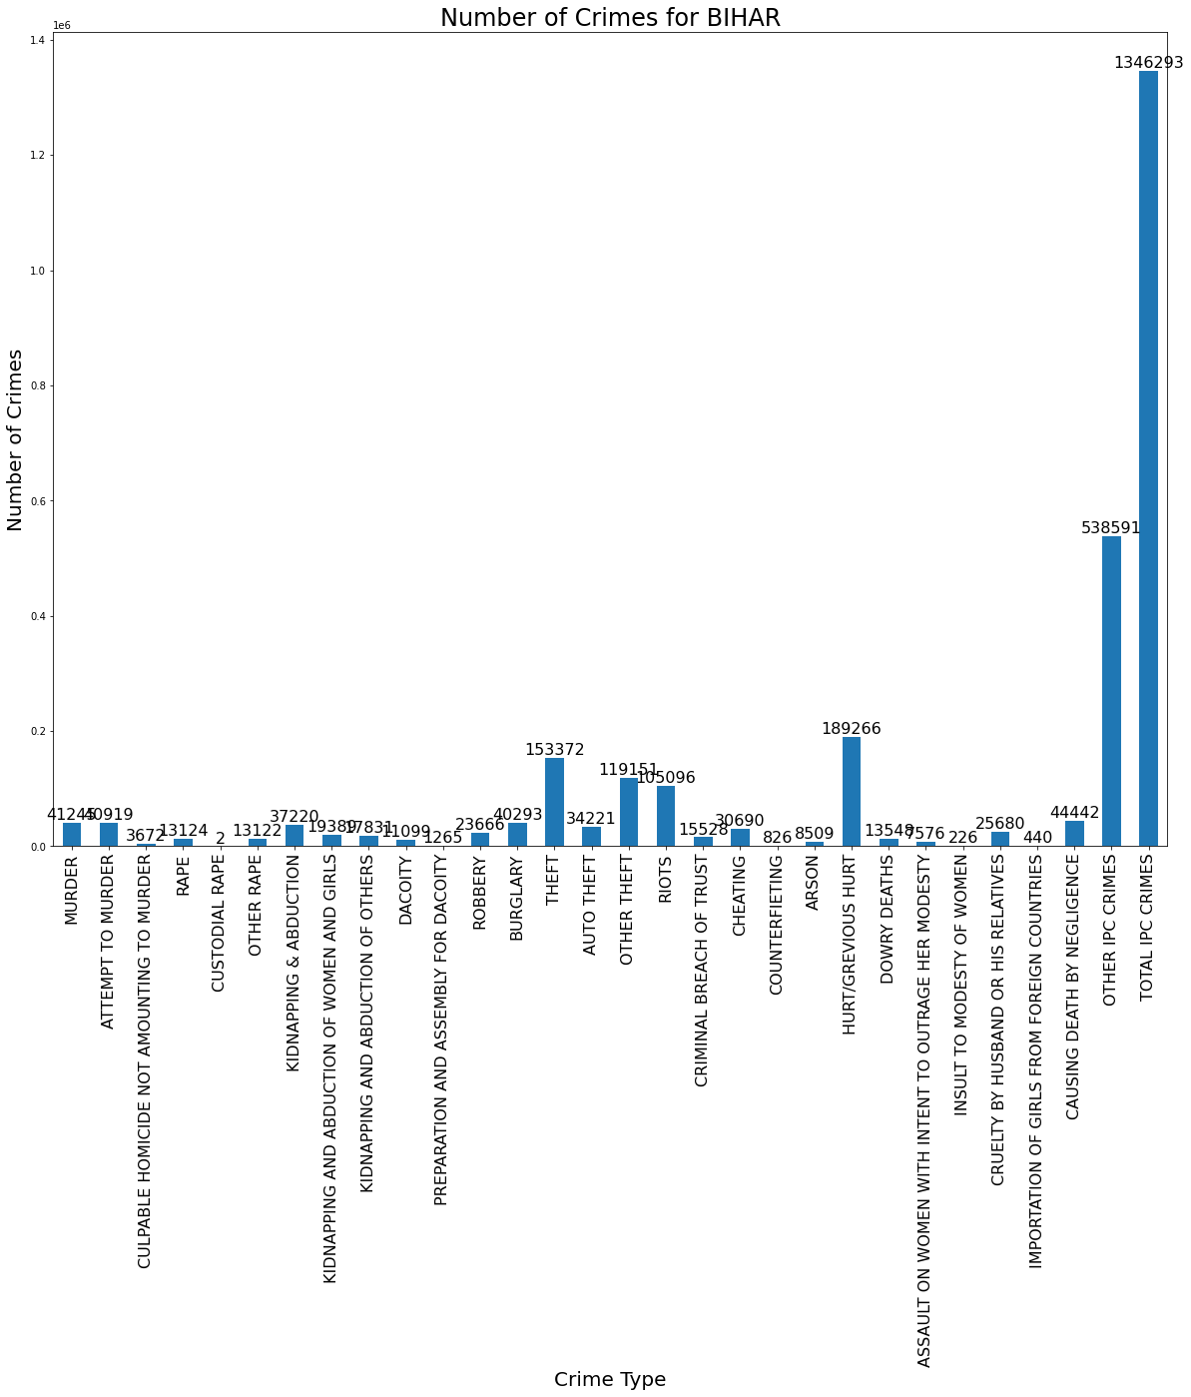

# From Above Graph We Observe That In Bihar The 'Theft','Hurt/Grevious Hurt','Other Ipc Crimes', 'Total Ipc Crimes' ,'Riots' Are More In This State.

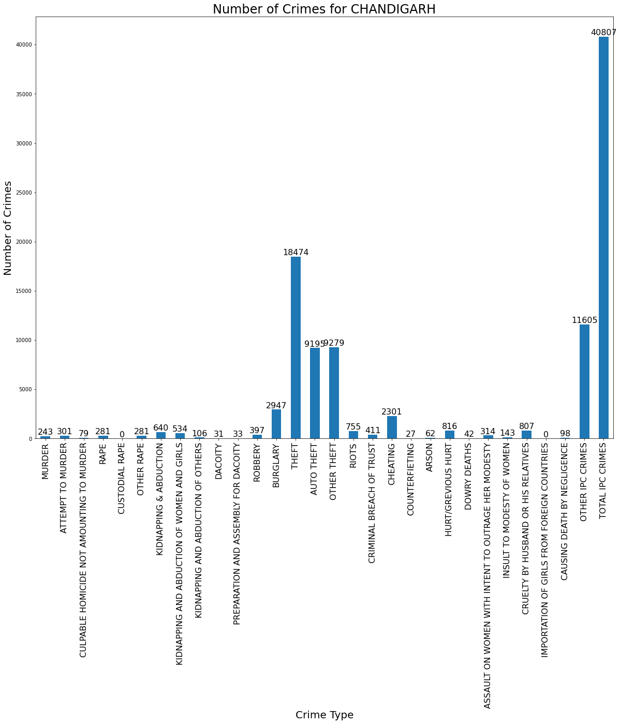

# From Above Graph We Observe That In Chandigarh The 'Burglary', 'Theft','Hurt/Grevious Hurt''other Ipc Crimes', 'Total Ipc Crimes' ,'Cheating' Are More In This State.

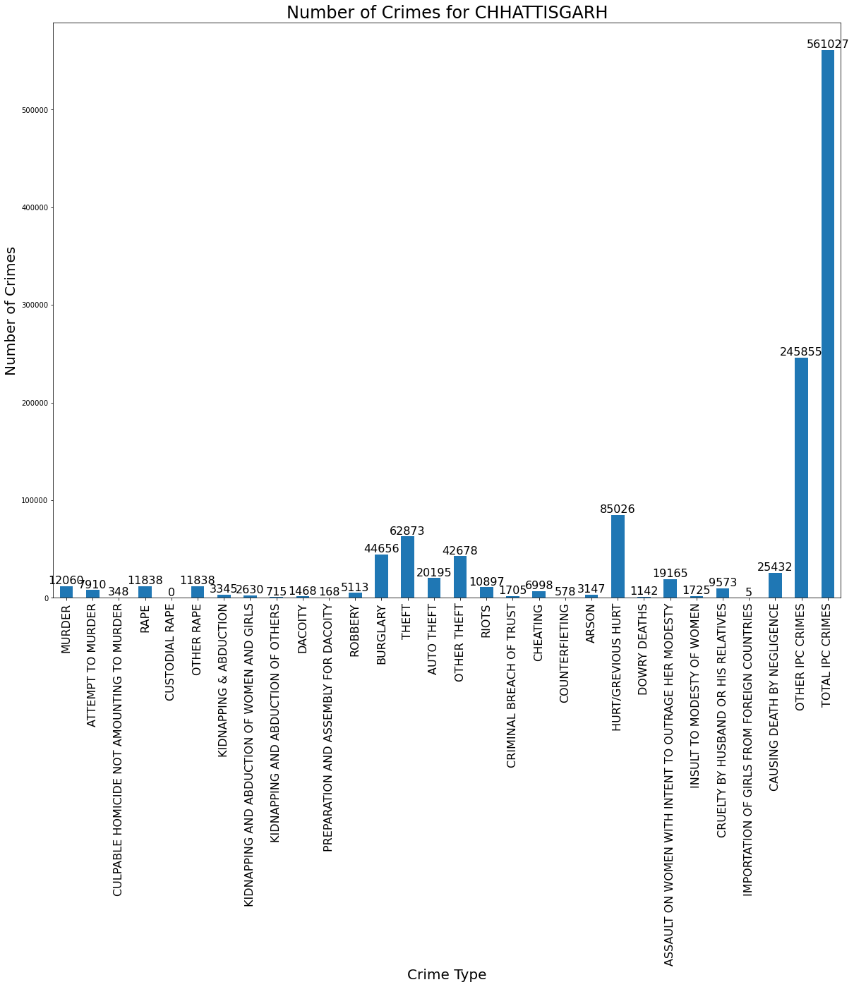

# From Above Graph We Observe That In Chhattisgarh The 'Burglary', 'Theft','Hurt/Grevious Hurt','Other Ipc Crimes', 'Total Ipc Crimes' , 'Causing Death By Negligence' Are More In This State.

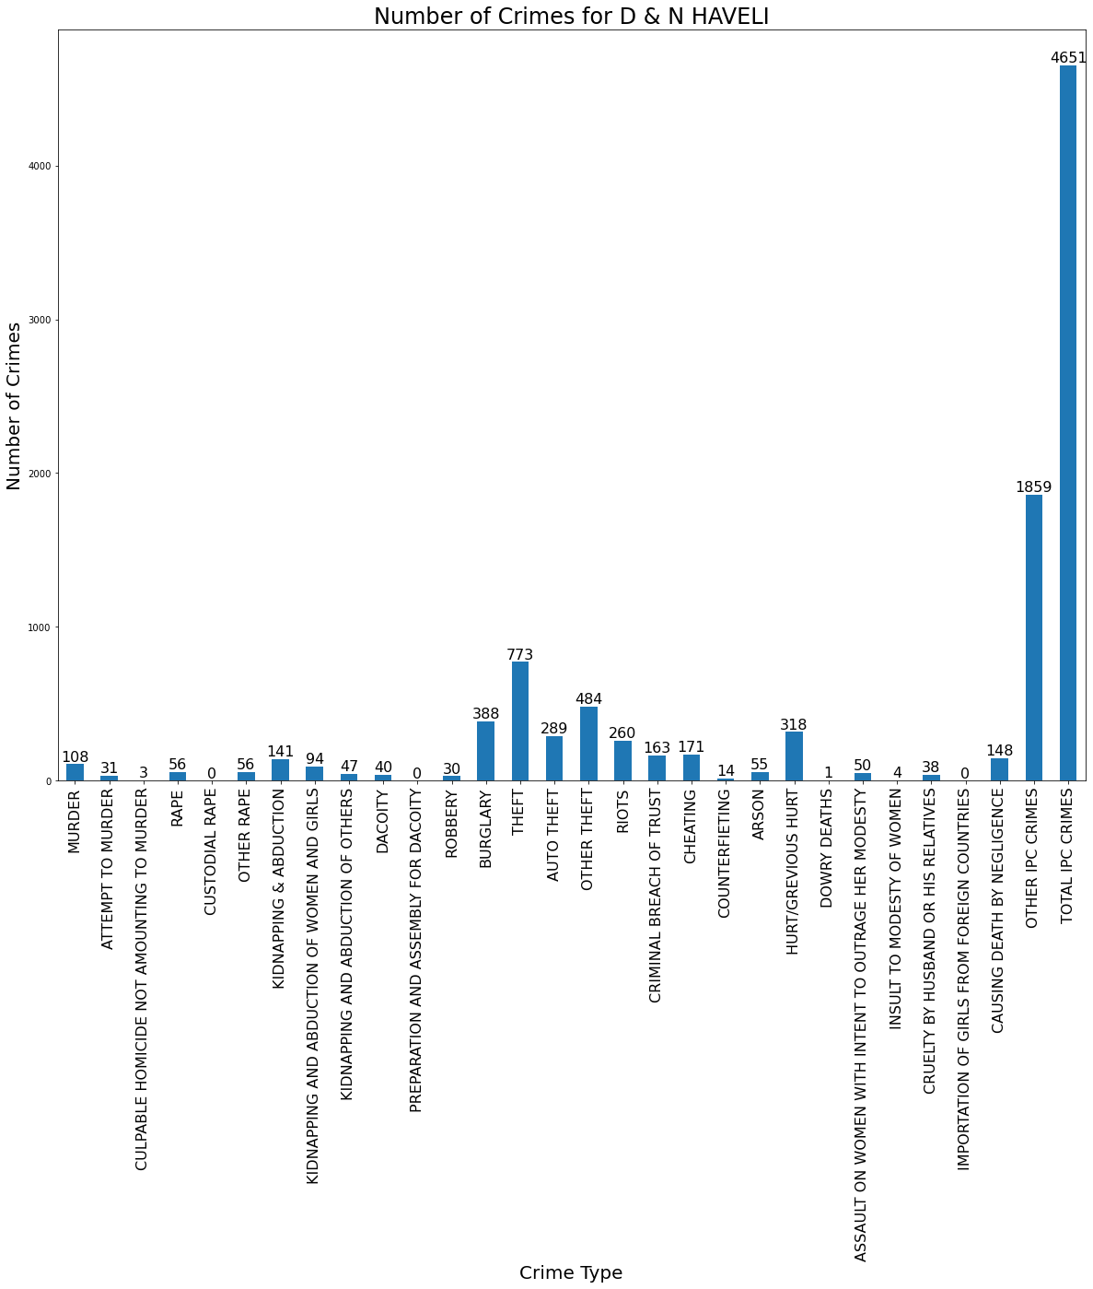

# From Above Graph We Observe That In D & N Haveli The 'Burglary', 'Theft','Hurt/Grevious Hurt','Other Ipc Crimes', 'Total Ipc Crimes' Are More In This State.

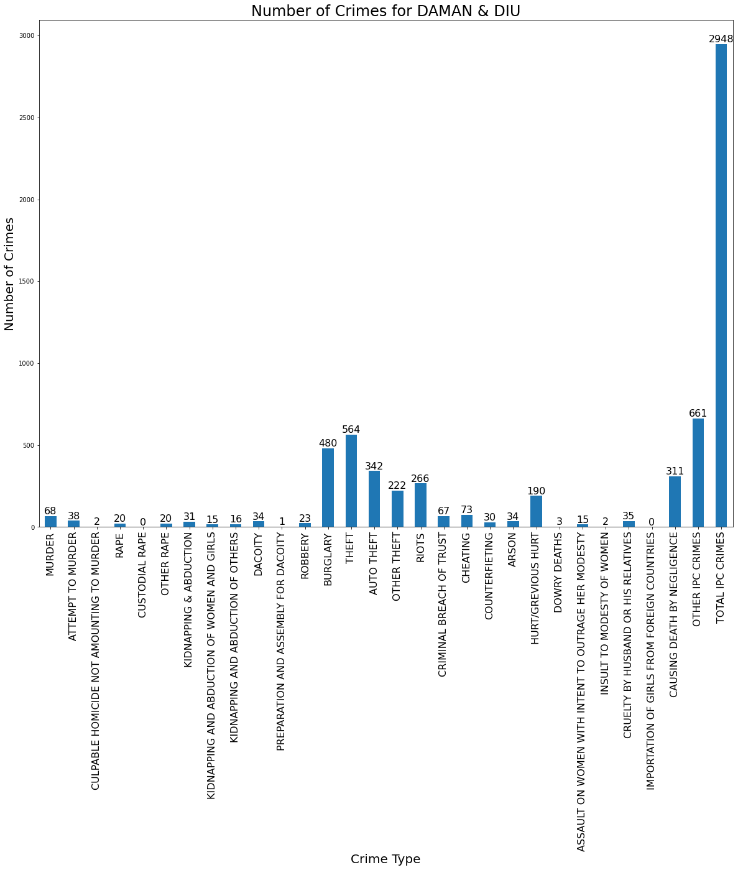

# From Above Graph We Observe That In Daman & Diu The 'Burglary', 'Theft','Hurt/Grevious Hurt','Other Ipc Crimes', 'Total Ipc Crimes' ,Cruelty By Husband Or His Relatives' , 'Causing Death By Negligence' ,'Riots', Are More In This State.

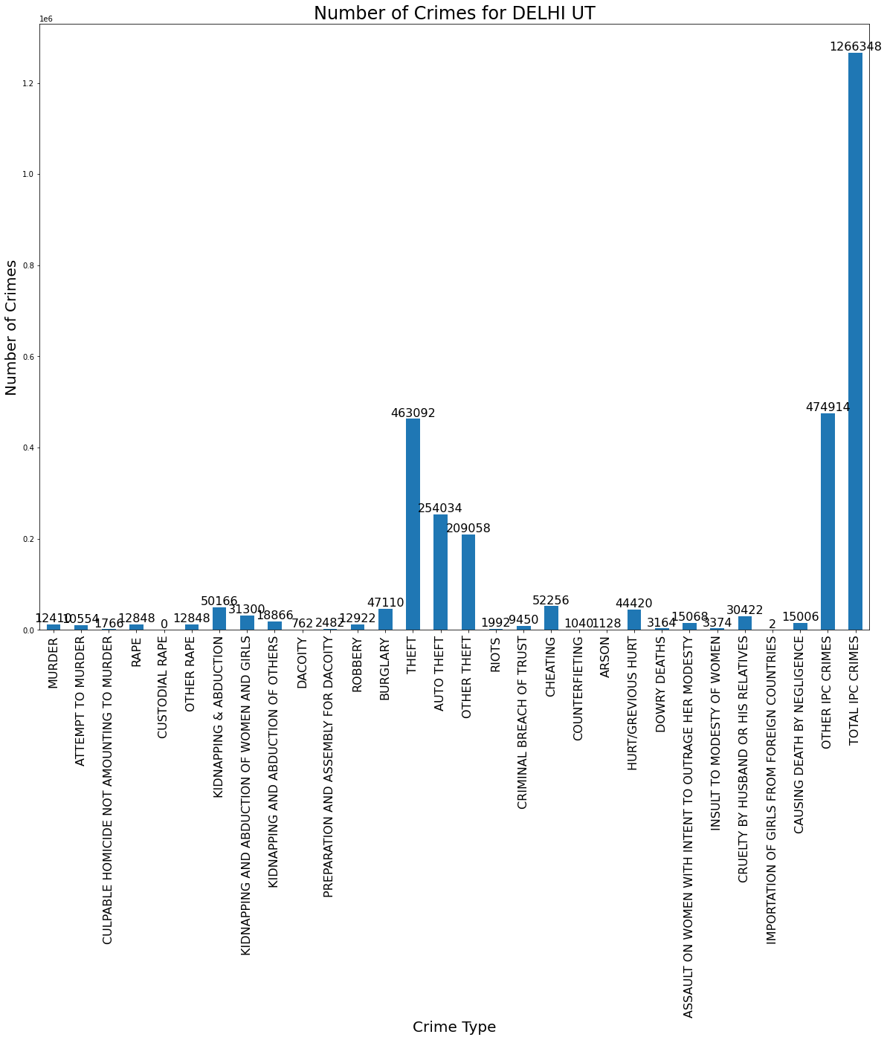

# From Above Graph We Observe That In Delhi Ut The 'Burglary', 'Theft','Hurt/Grevious Hurt','Other Ipc Crimes', 'Total Ipc Crimes' ,Cruelty By Husband Or His Relatives' , 'Causing Death By Negligence' ,'Cheating' Are More In This State.

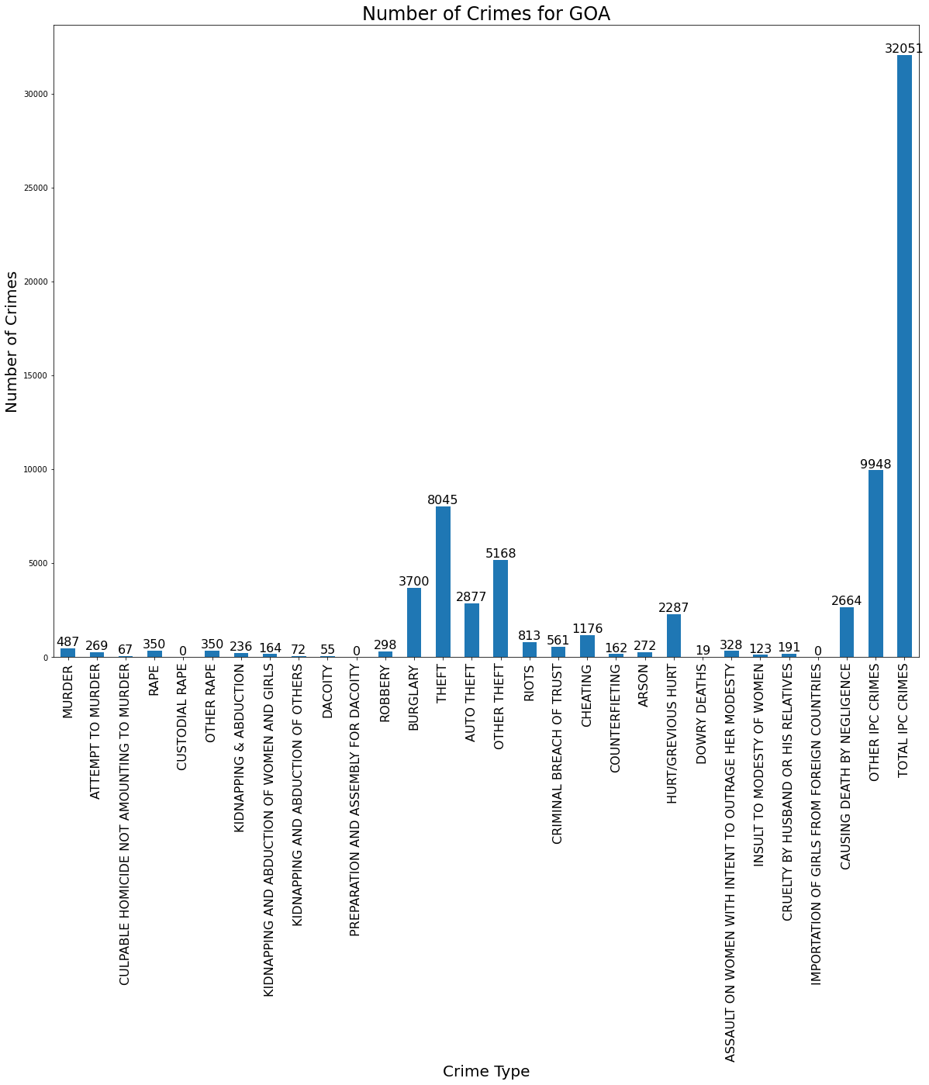

# From Above Graph We Observe That In Goa The 'Burglary', 'Theft','Hurt/Grevious Hurt','Other Ipc Crimes', 'Total Ipc Crimes' ,Cruelty By Husband Or His Relatives' , 'Causing Death By Negligence','Cheating', Are More In This State.

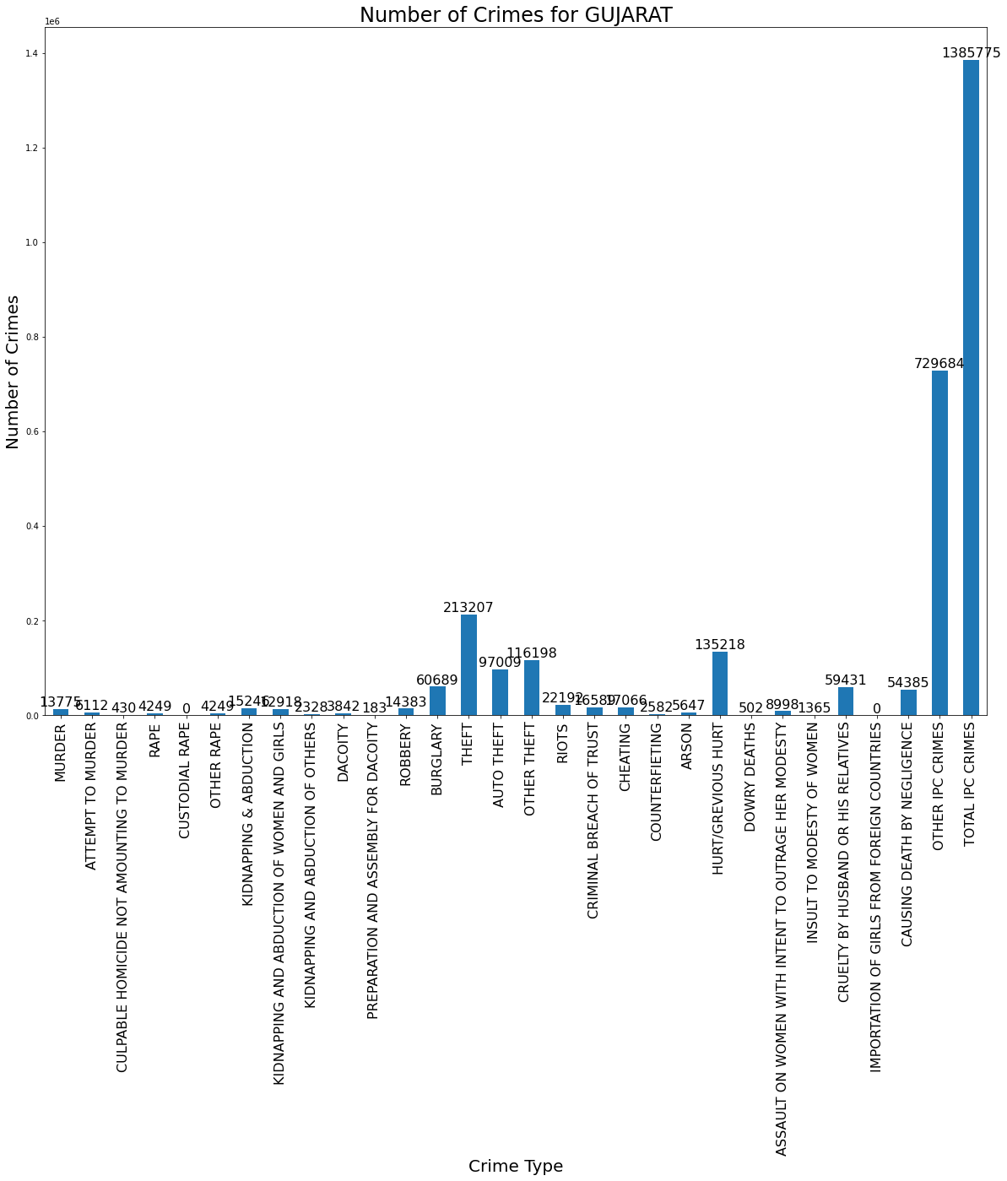

# From Above Graph We Observe That In Gujarat The 'Burglary', 'Theft','Hurt/Grevious Hurt','Other Ipc Crimes', 'Total Ipc Crimes' ,Cruelty By Husband Or His Relatives' , 'Causing Death By Negligence' Are More In This State.

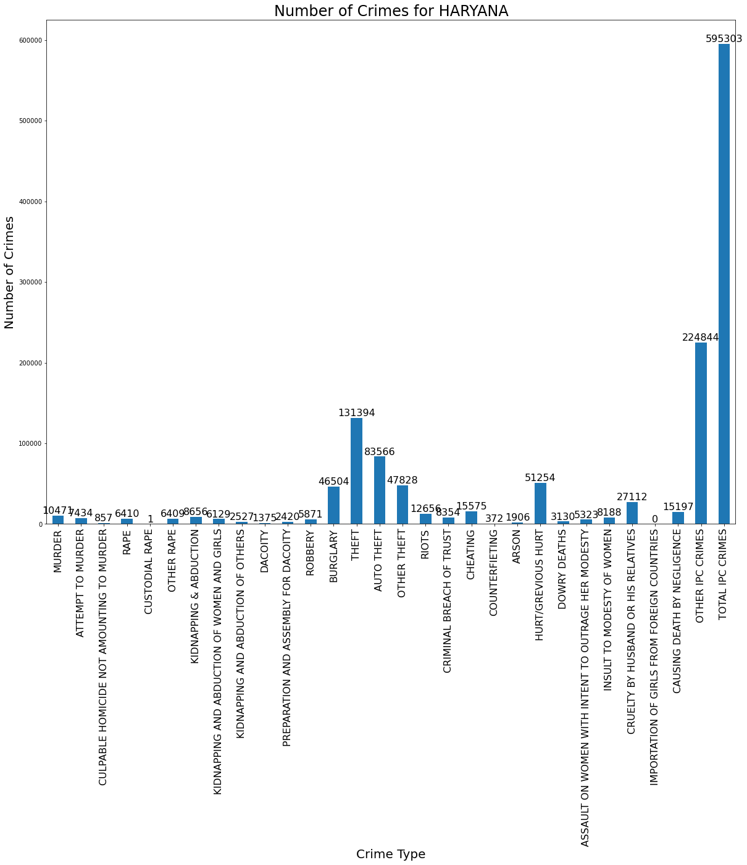

# From Above Graph We Observe That In Haryana The 'Burglary', 'Theft','Hurt/Grevious Hurt','Other Ipc Crimes', 'Total Ipc Crimes' ,'Hurt/Grevious Hurt' Are More In This State.

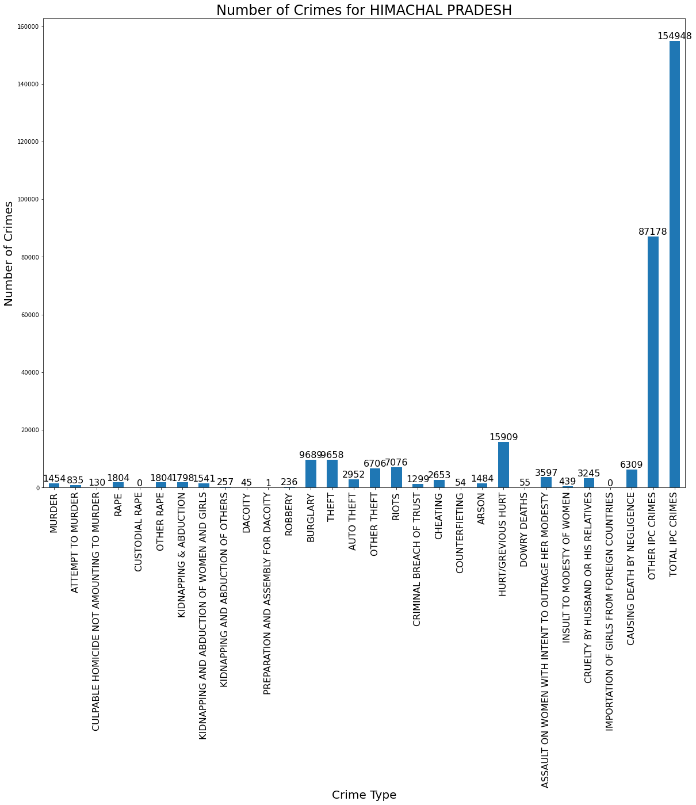

# From Above Graph We Observe That In Himachal Pradesh The 'Burglary', 'Theft','Hurt/Grevious Hurt','Other Ipc Crimes', 'Total Ipc Crimes' ,'Hurt/Grevious Hurt' Are More In This State.

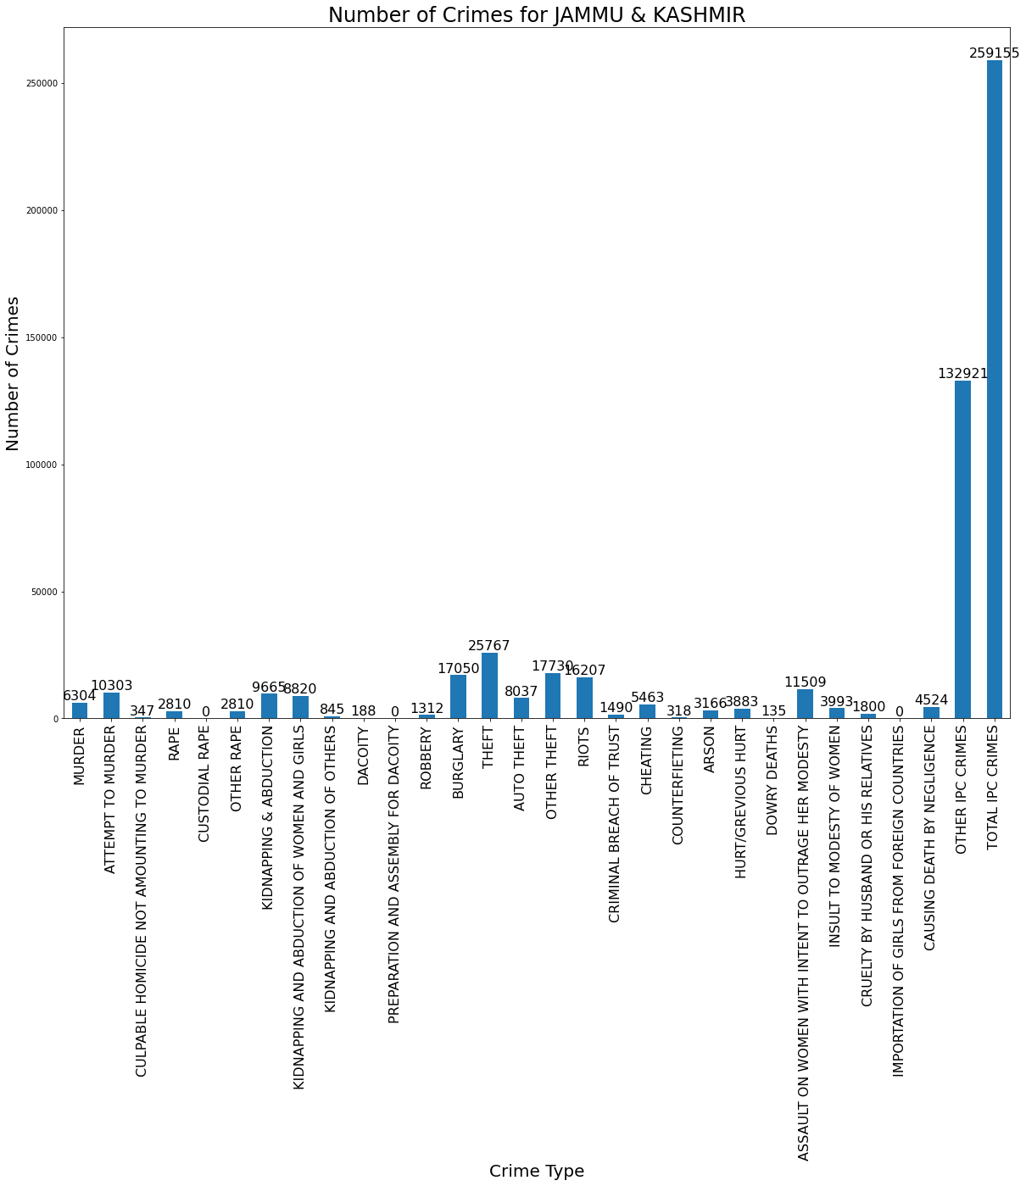

# From Above Graph We Observe That In Himachal Pradesh The 'Burglary', 'Theft','Hurt/Grevious Hurt','Other Ipc Crimes', 'Total Ipc Crimes' ,'Hurt/Grevious Hurt' Are More In This State.

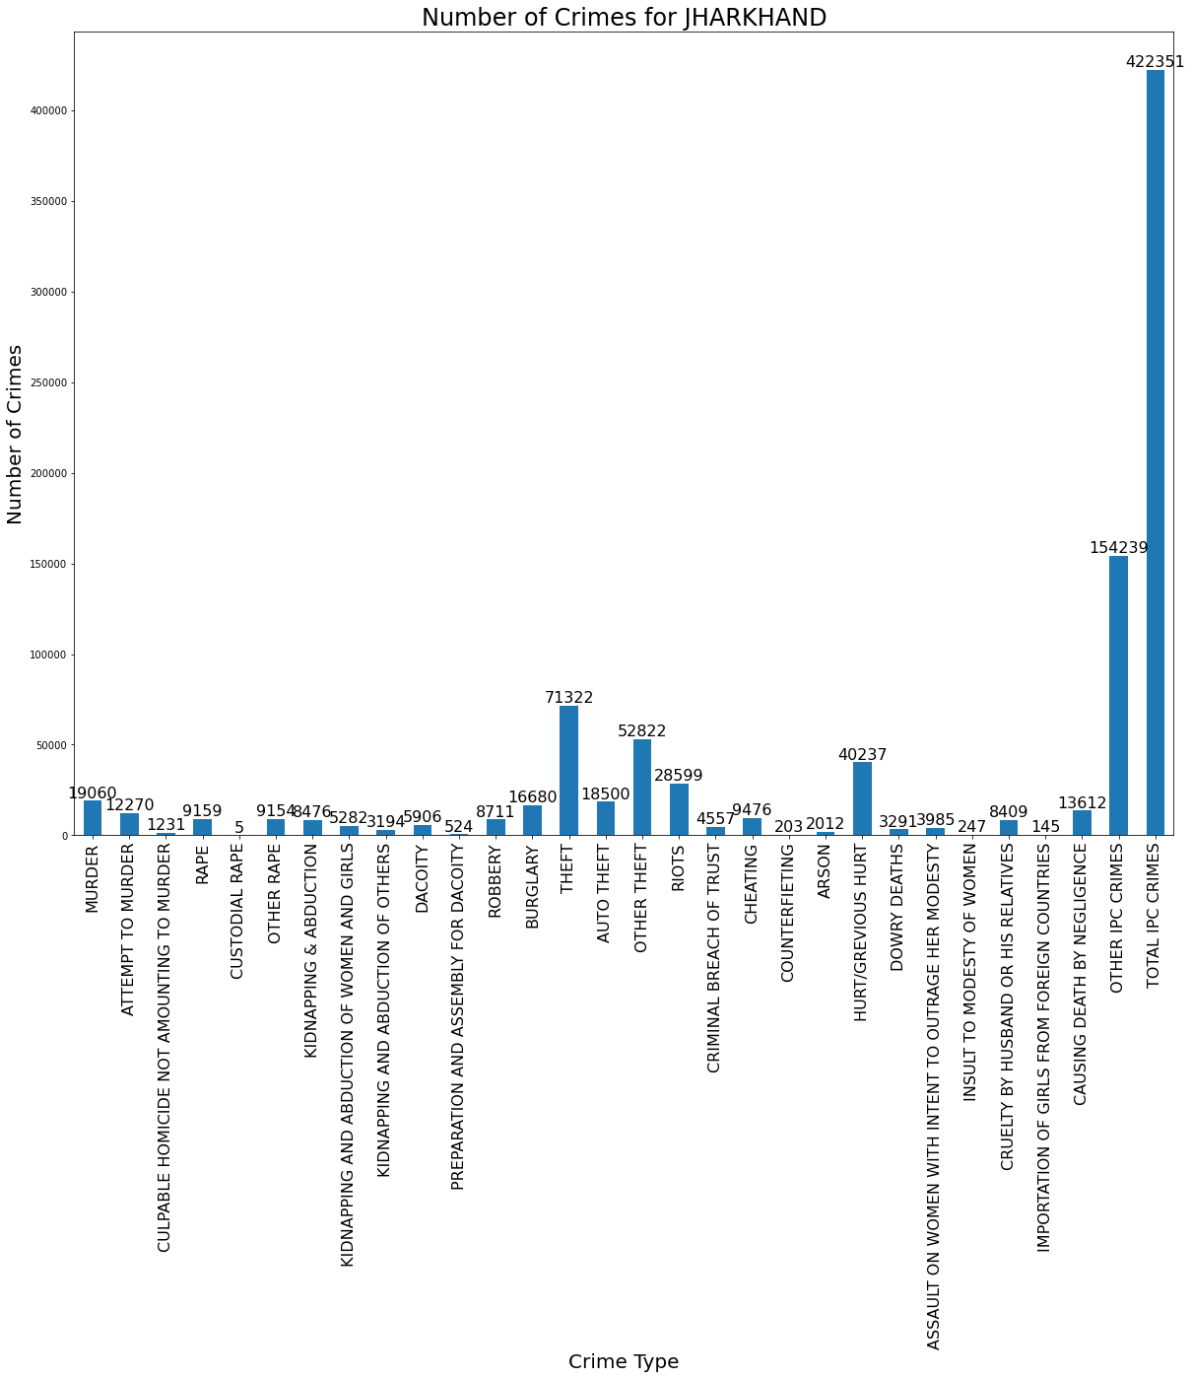

# From Above Graph We Observe That In Jharkhand The 'Theft','Hurt/Grevious Hurt','Other Ipc Crimes', 'Total Ipc Crimes' Are More In This State.

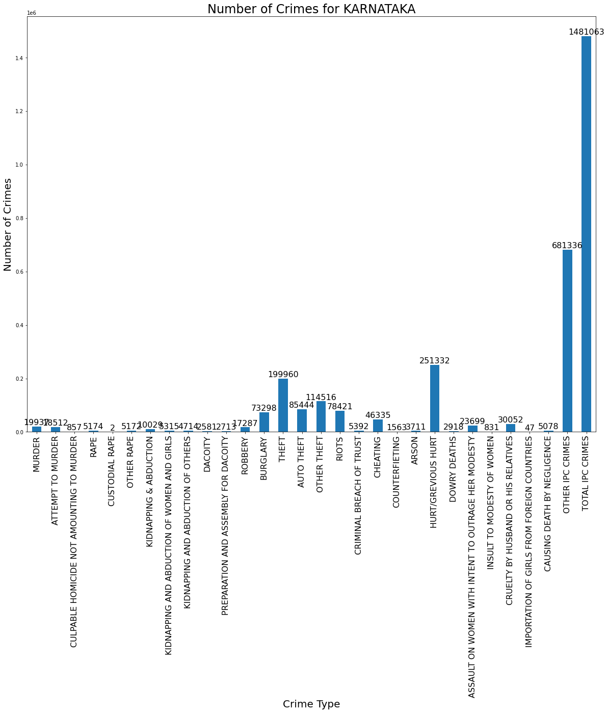

# From Above Graph We Observe That In Karnataka The 'Burglary', 'Theft','Hurt/Grevious Hurt','Other Ipc Crimes', 'Total Ipc Crimes' Are More In This State.

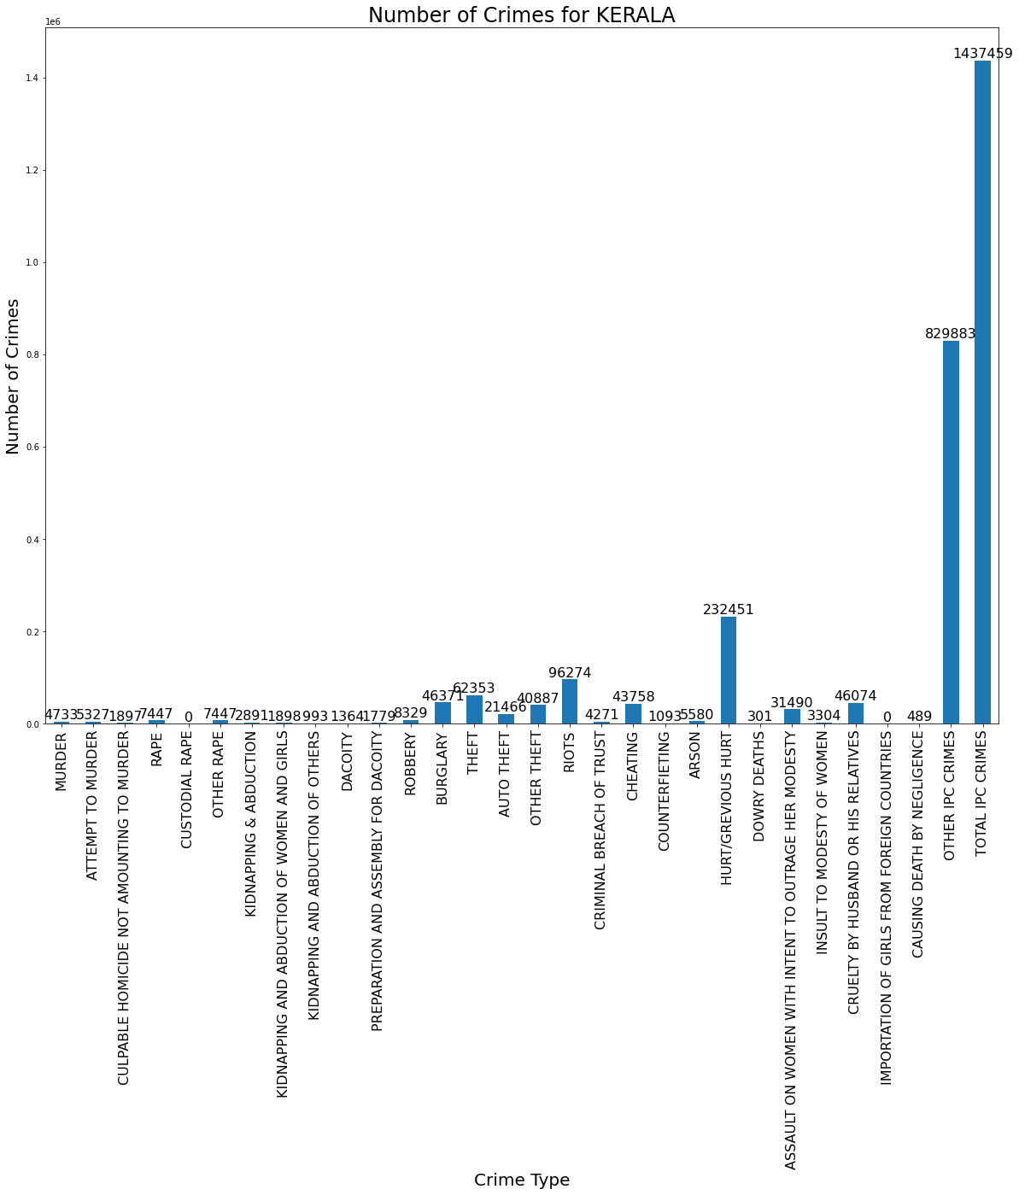

# From Above Graph We Observe That In Kerala The 'Burglary', 'Theft','Hurt/Grevious Hurt','Other Ipc Crimes', 'Total Ipc Crimes' ,'Riots' Are More In This State.

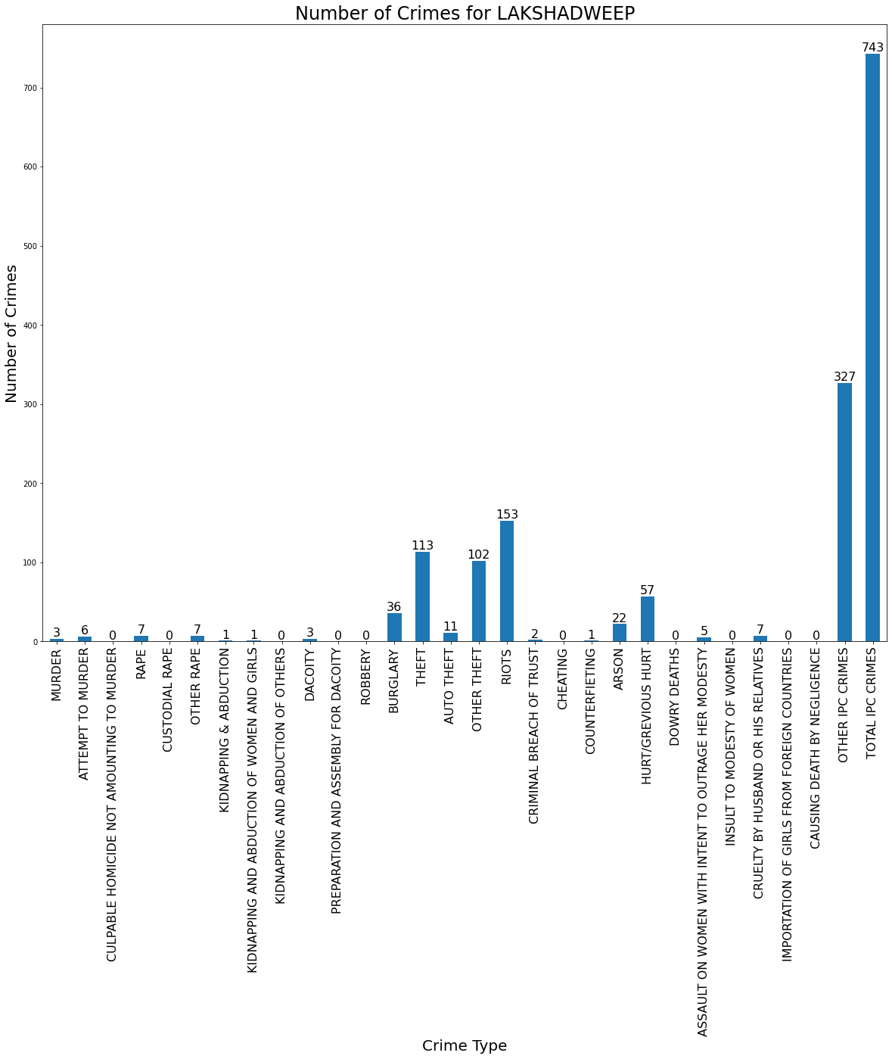

# From Above Graph We Observe That In Lakshadweep The 'Burglary', 'Theft','Hurt/Grevious Hurt','Other Ipc Crimes', 'Total Ipc Crimes' ,'Riots' Are More In This State.

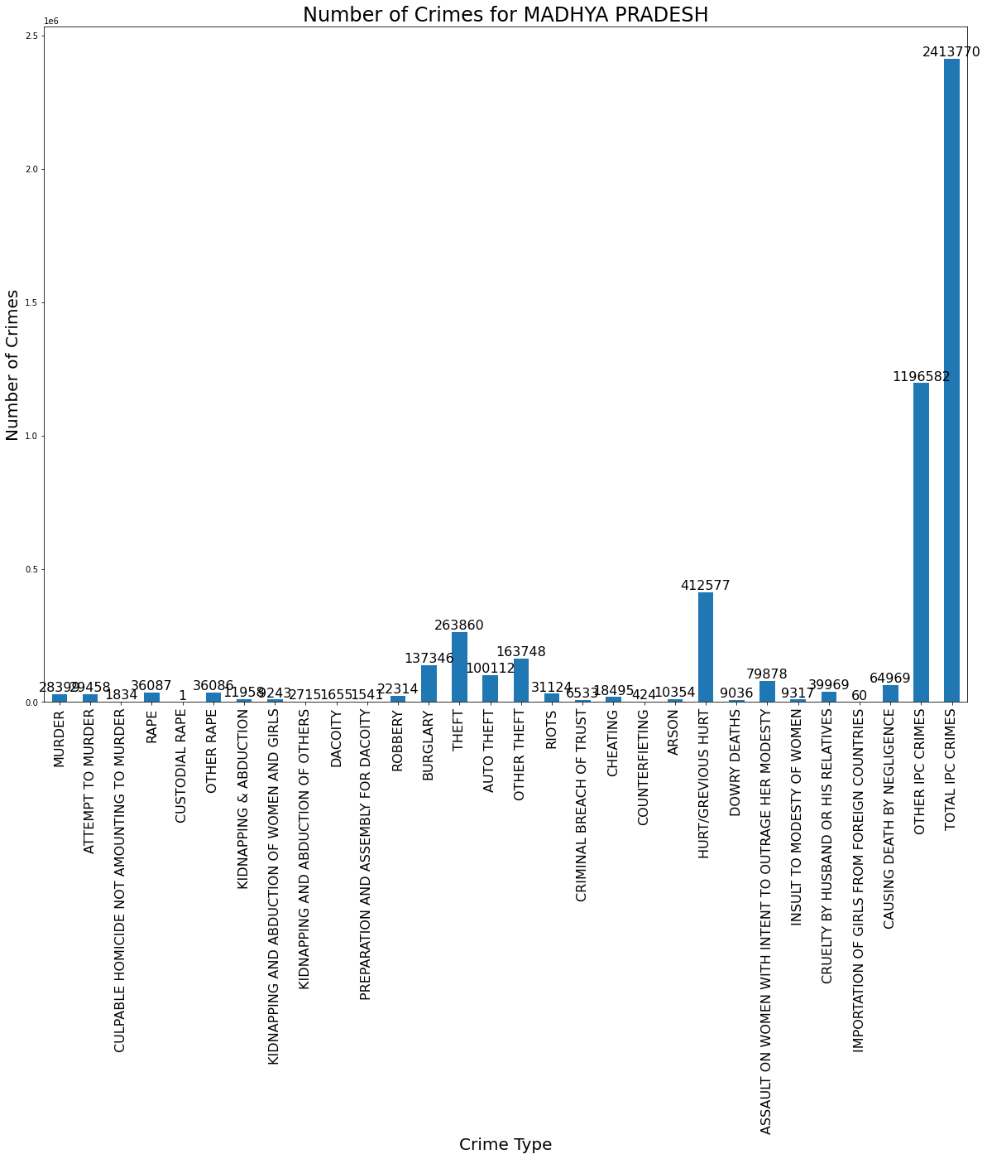

# From Above Graph We Observe That In Madhya Pradesh The 'Burglary', 'Theft','Hurt/Grevious Hurt','Other Ipc Crimes', 'Total Ipc Crimes' , Are More In This State.

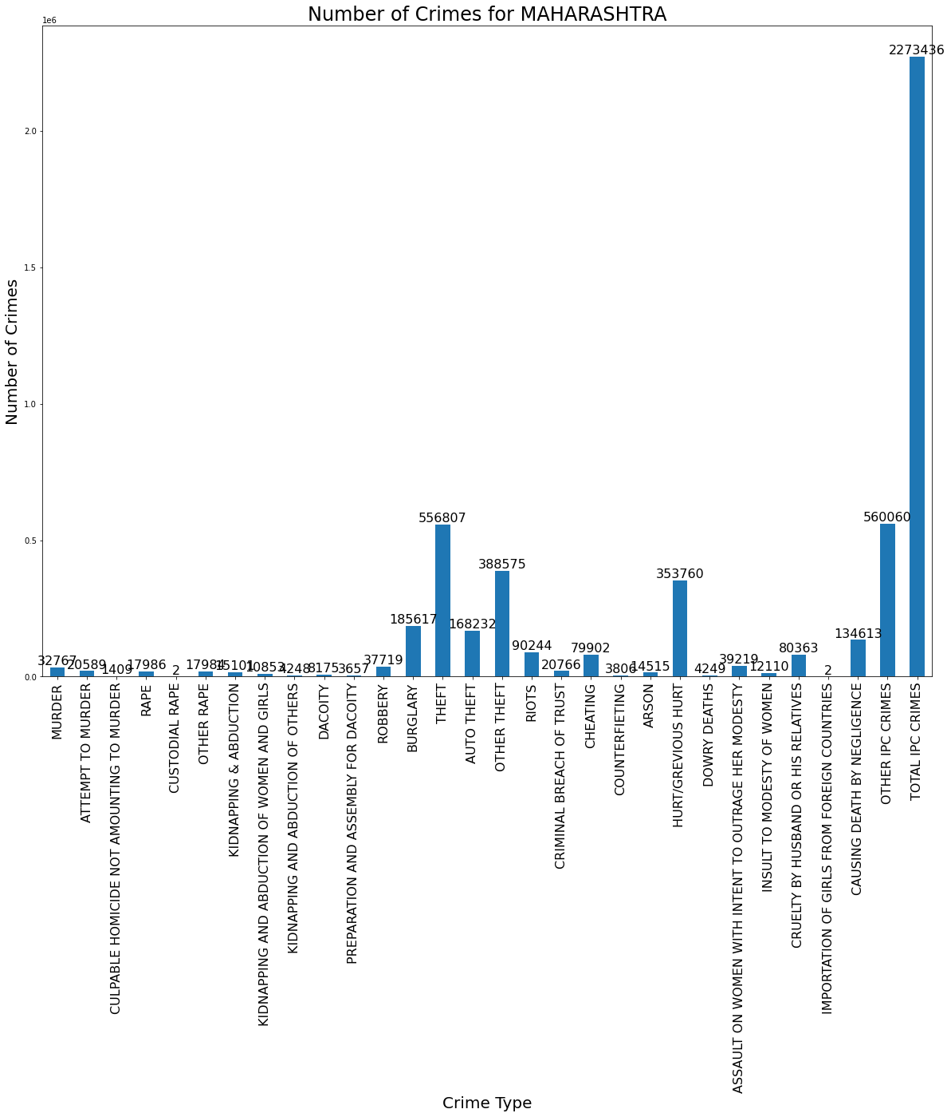

# From Above Graph We Observe That In Maharashtra The 'Burglary', 'Theft','Hurt/Grevious Hurt','Other Ipc Crimes', 'Total Ipc Crimes' ,Cruelty By Husband Or His Relatives' , 'Causing Death By Negligence' , 'Cheating' Are More In This State.

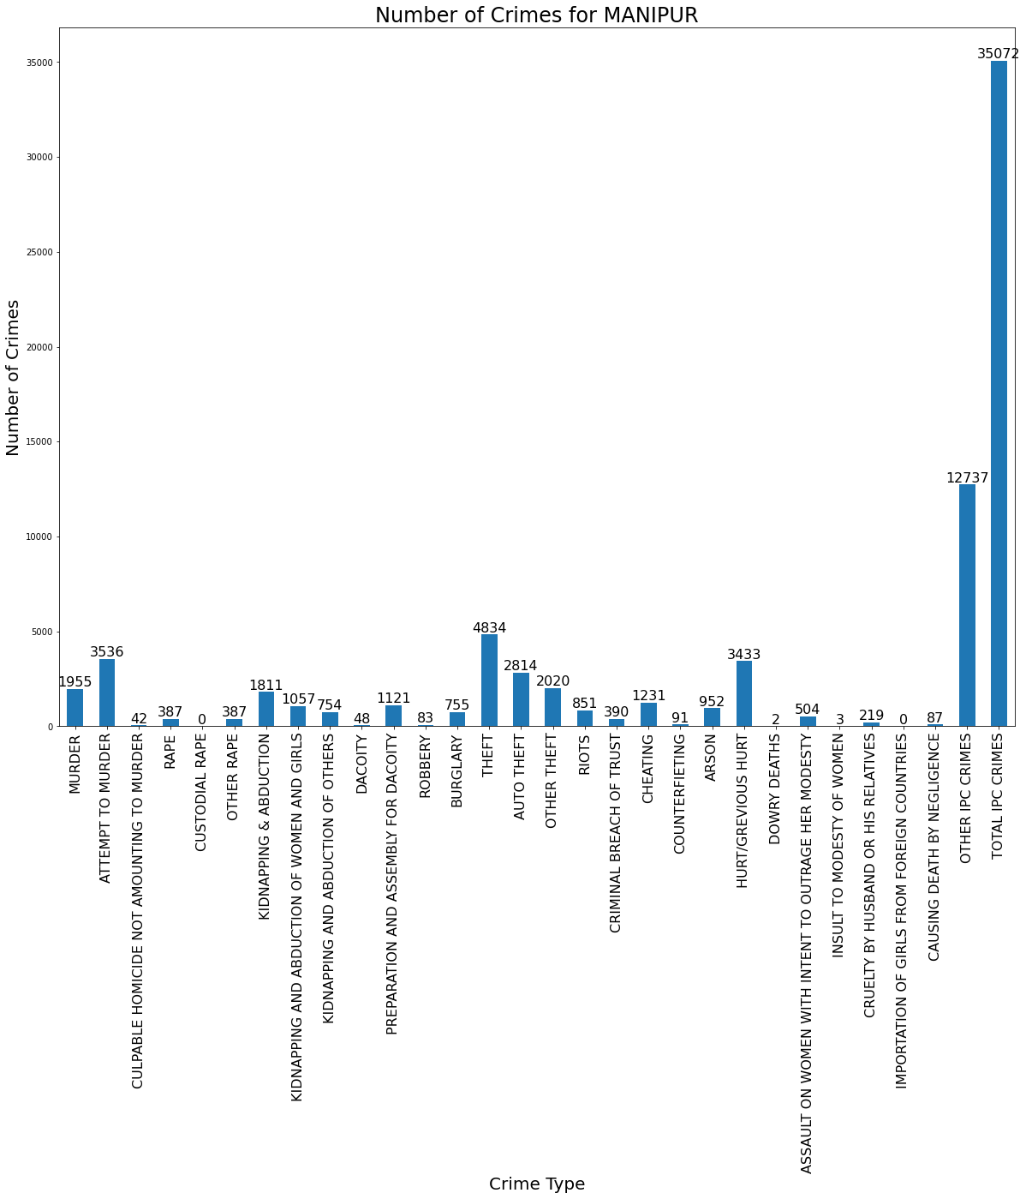

# From Above Graph We Observe That In Manipur The 'Theft','Hurt/Grevious Hurt','Other Ipc Crimes', 'Total Ipc Crimes' ,'Murder' , 'Attempt To Murder' Are More In This State.

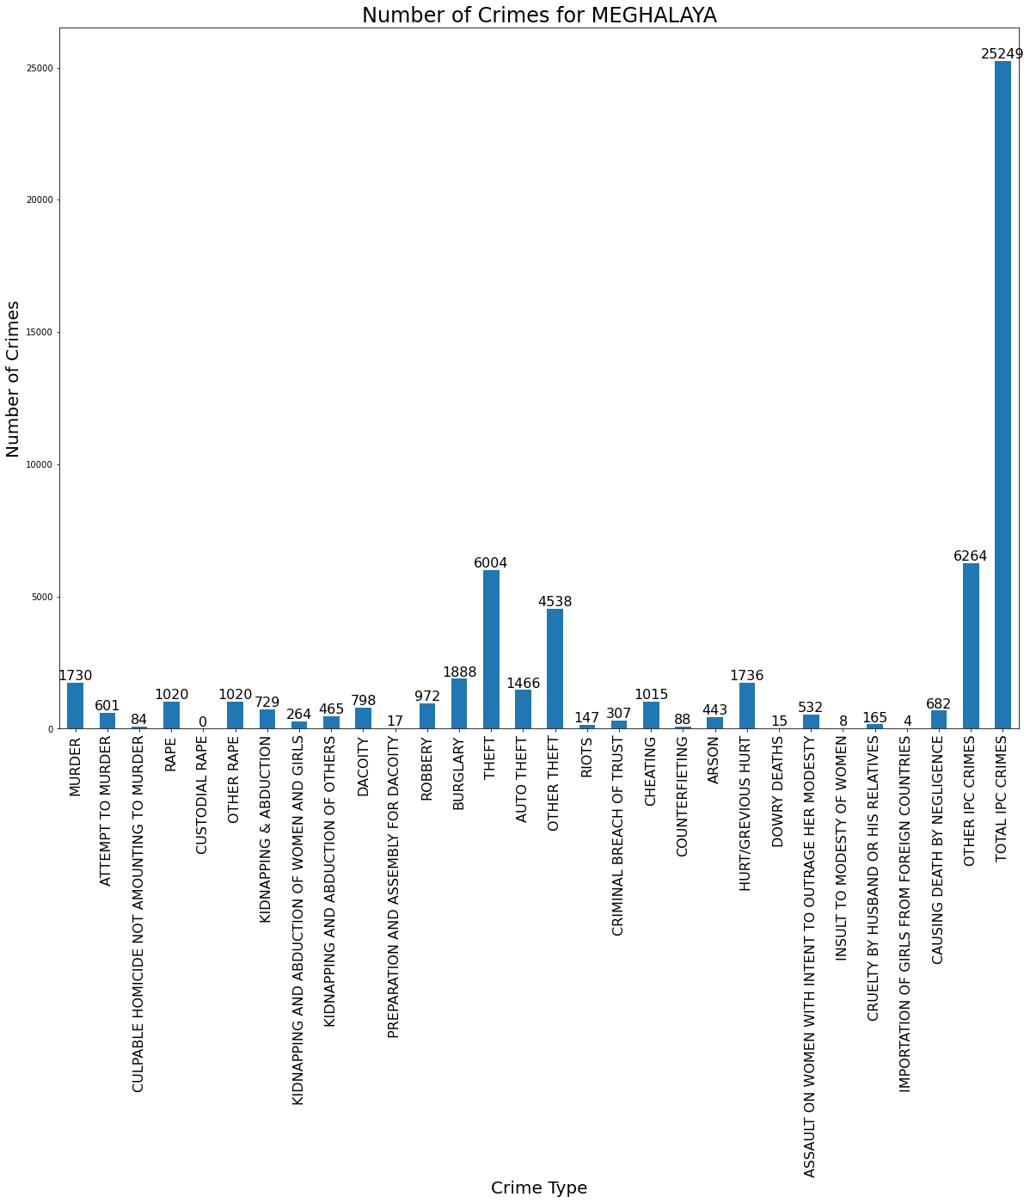

# From Above Graph We Observe That In Meghalaya The 'Burglary', 'Theft','Hurt/Grevious Hurt','Other Ipc Crimes', 'Total Ipc Crimes' ,'Robbery' , 'Rape' , 'Murder' Are More In This State.

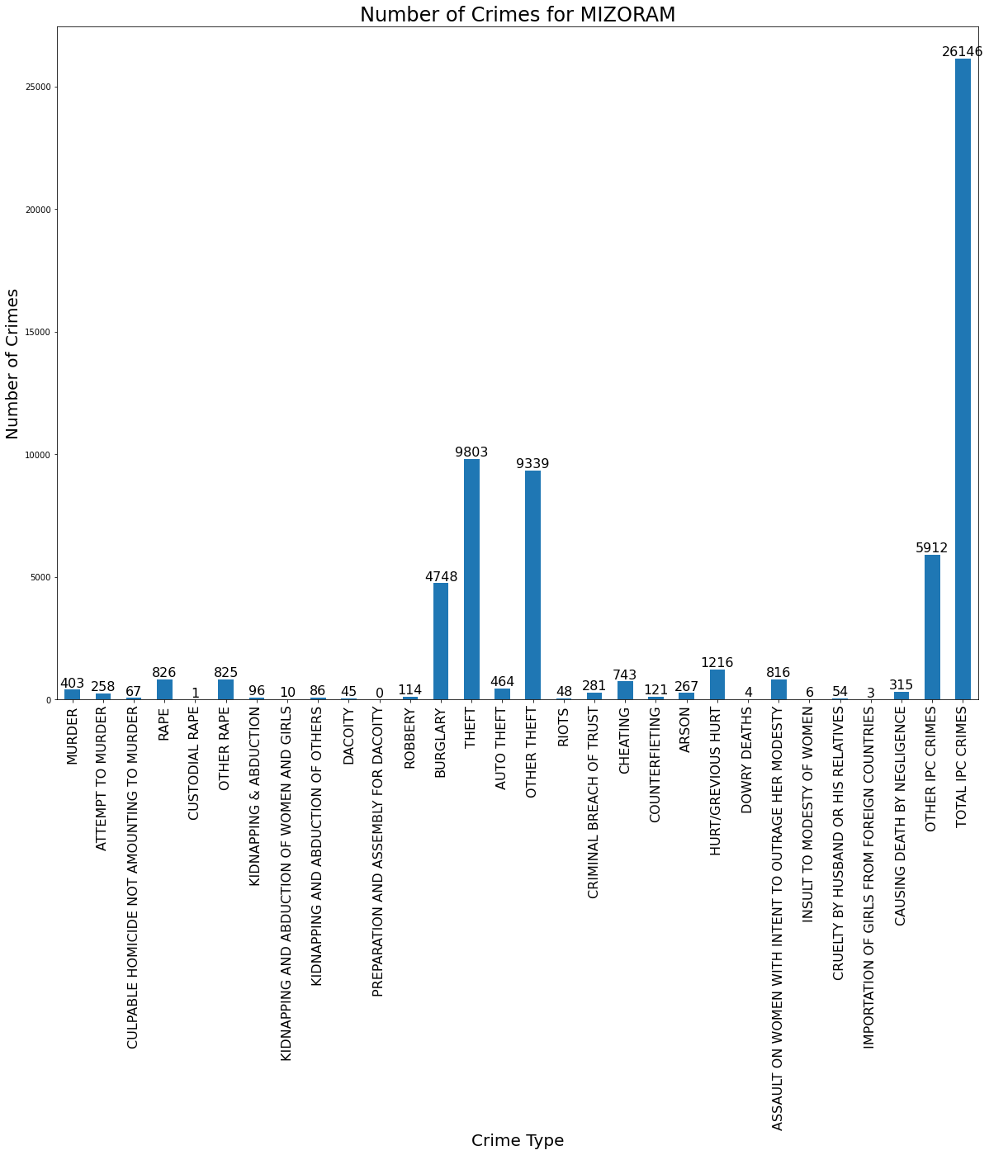

# From Above Graph We Observe That In Mizoram The 'Burglary', 'Theft','Hurt/Grevious Hurt','Other Ipc Crimes', 'Total Ipc Crimes' Are More In This State.

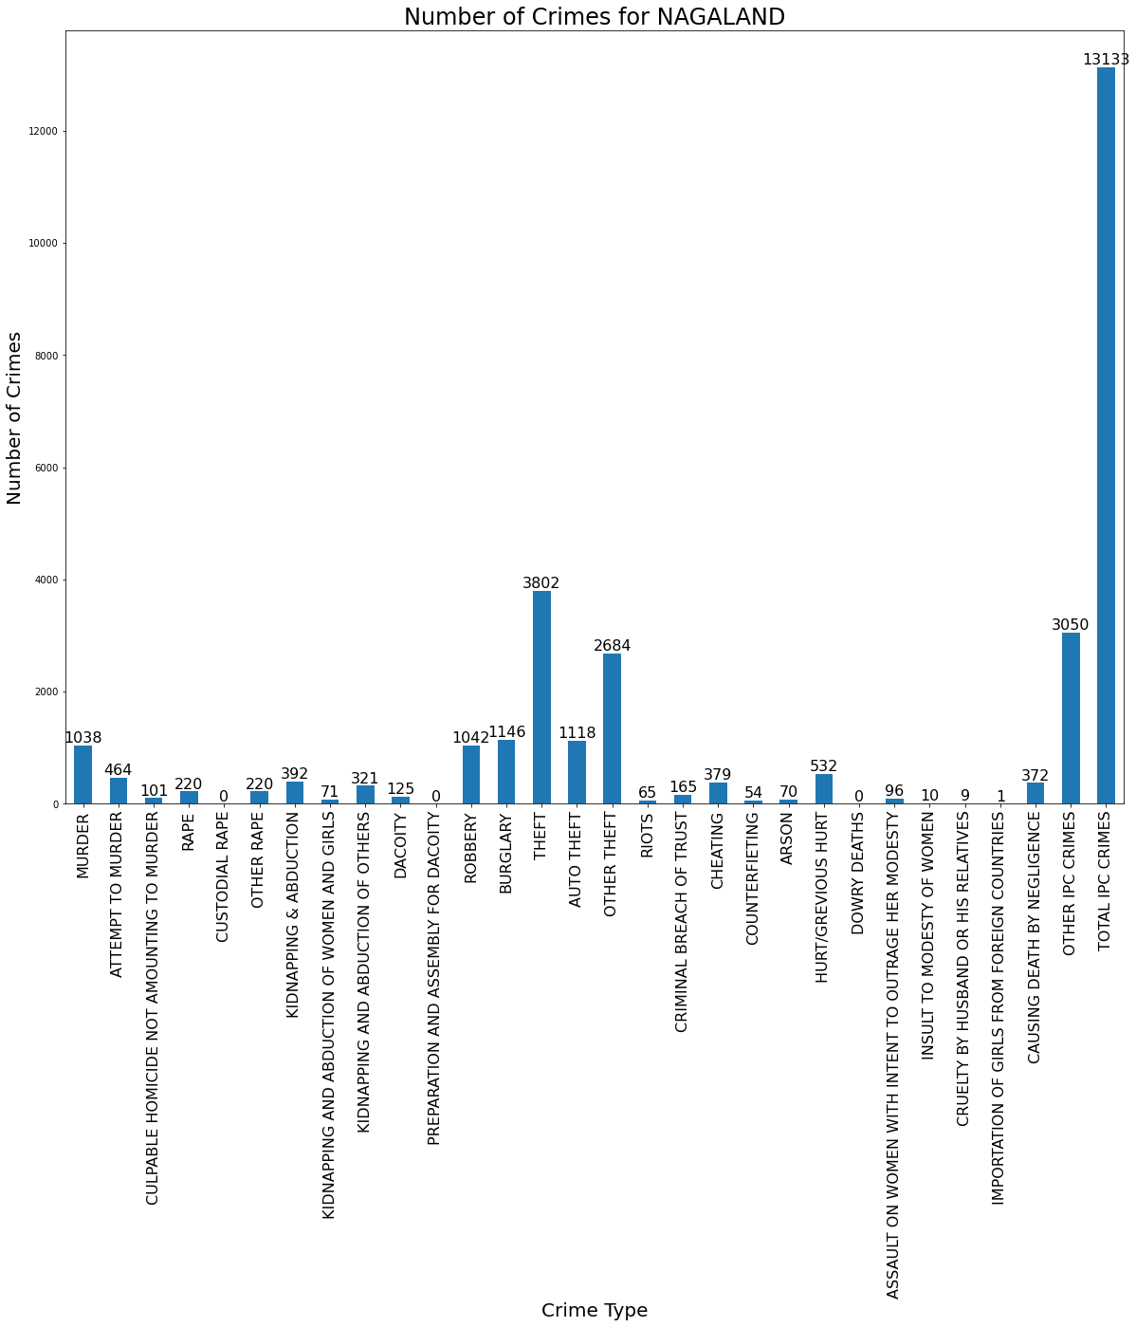

# From Above Graph We Observe That In Nagaland The 'Burglary', 'Theft','Hurt/Grevious Hurt','Other Ipc Crimes', 'Total Ipc Crimes' ,'Murder','Robbery' Are More In This State.

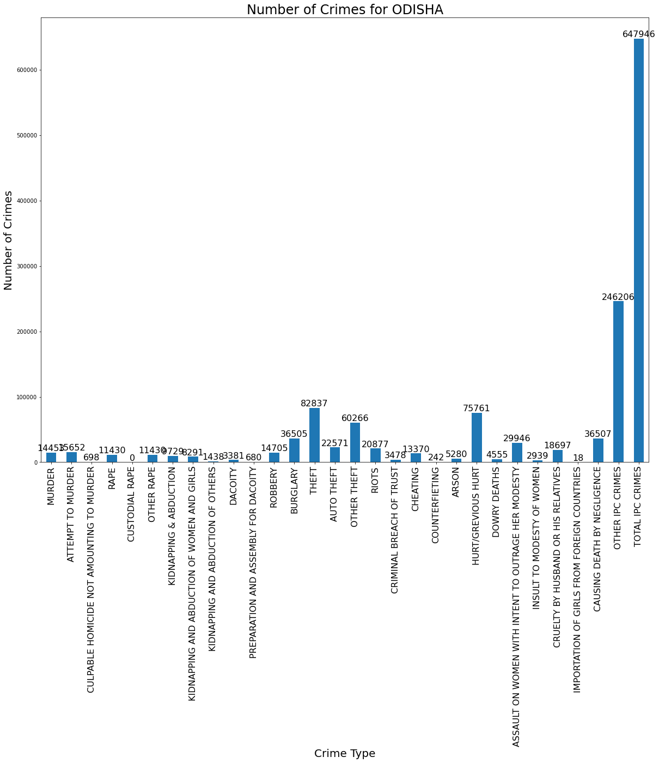

# From Above Graph We Observe That In Odisha The 'Burglary', 'Theft','Hurt/Grevious Hurt','Other Ipc Crimes', 'Total Ipc Crimes' Are More In This State.

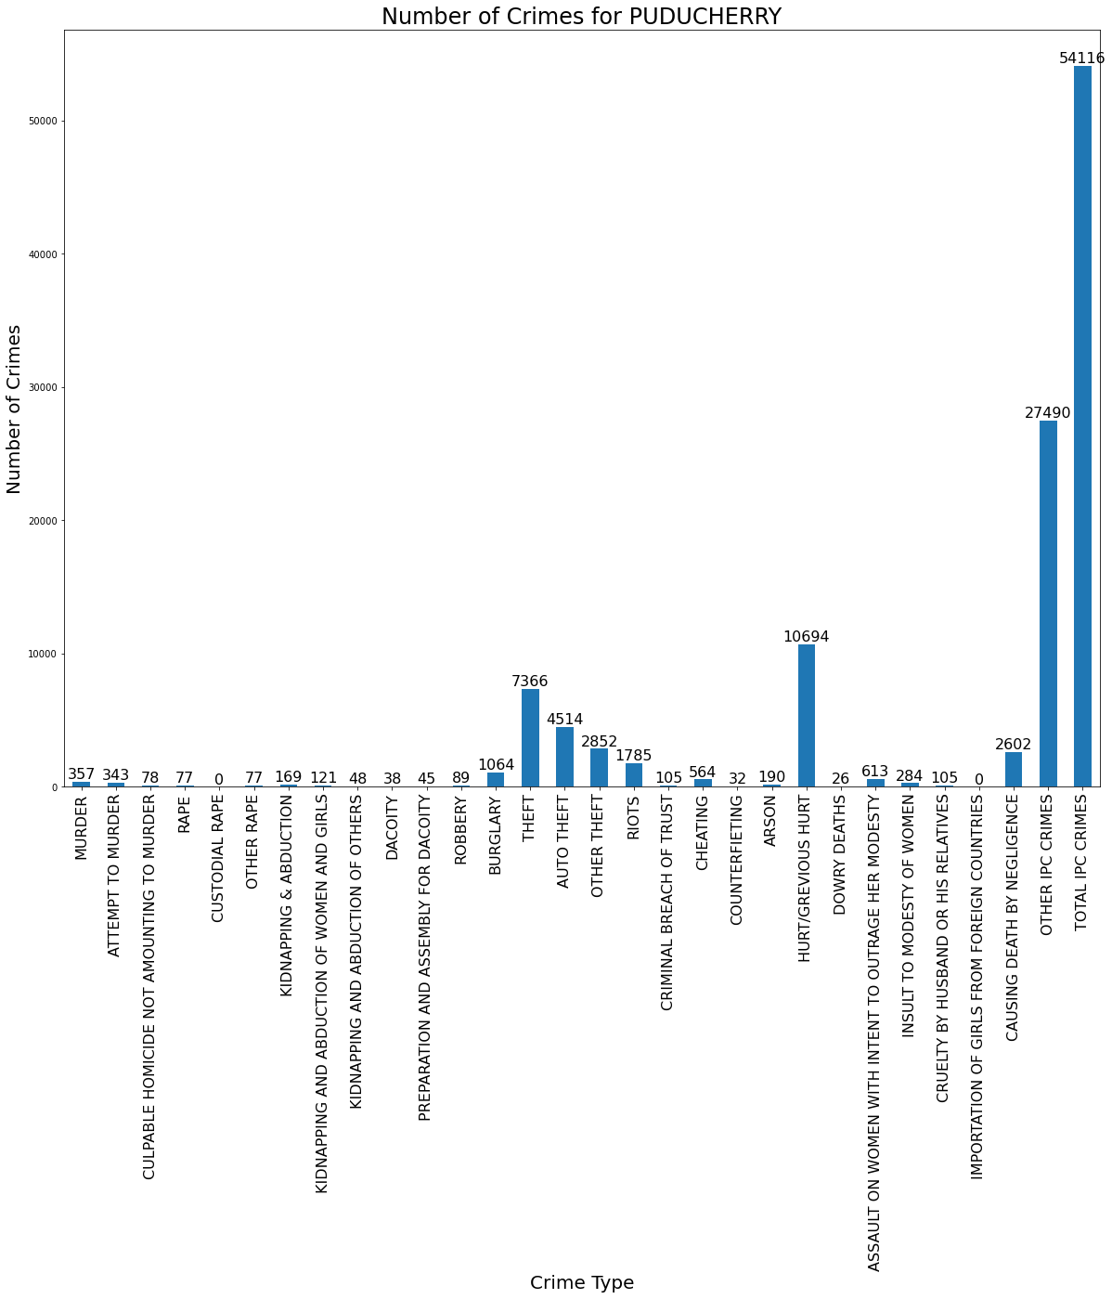

# From Above Graph We Observe That In Puducherry The, 'Theft','Hurt/Grevious Hurt','Other Ipc Crimes', 'Total Ipc Crimes' Are More In This State.

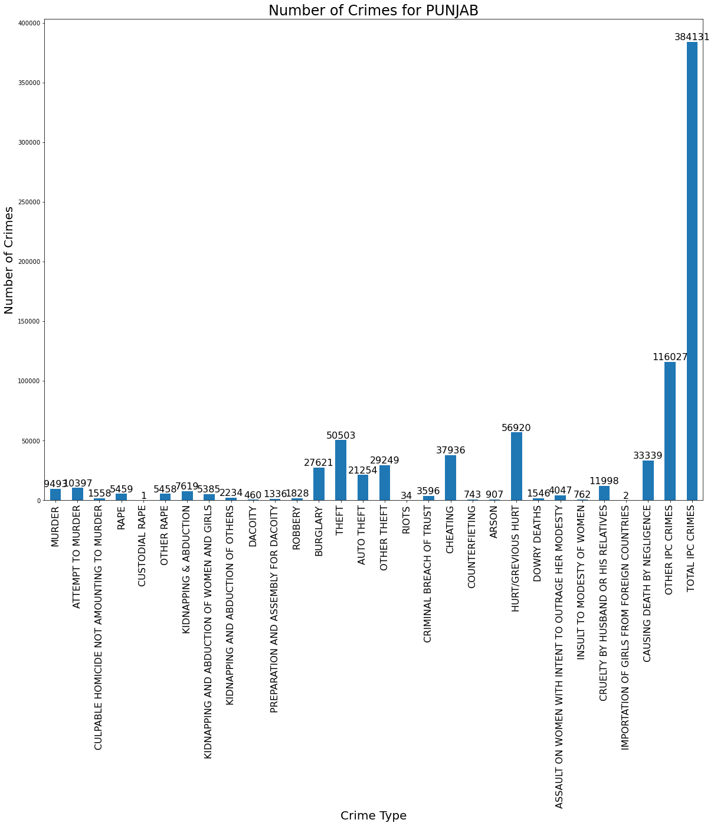

# From Above Graph We Observe That In Punjab The 'Burglary', 'Theft','Hurt/Grevious Hurt','Other Ipc Crimes', 'Total Ipc Crimes' ,'Cheating' , 'Causing Death By Negligence' Are More In This State.

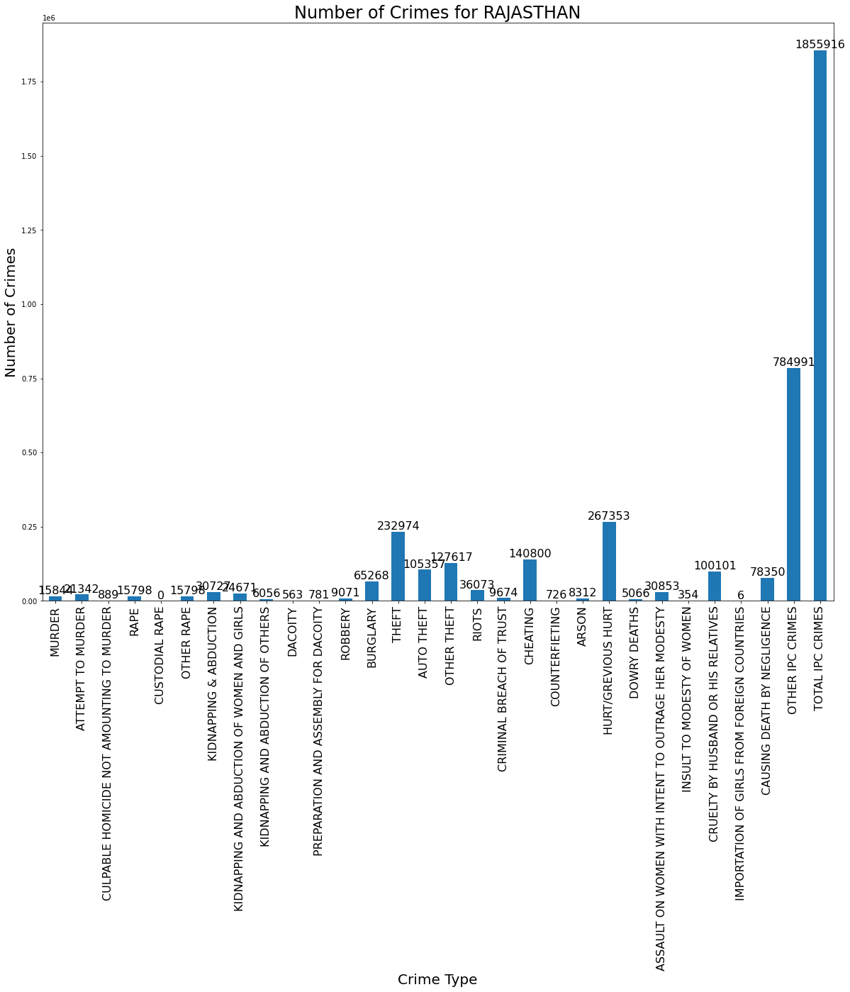

# From Above Graph We Observe That In Rajasthan The 'Burglary', 'Theft','Hurt/Grevious Hurt','Other Ipc Crimes', 'Total Ipc Crimes' ,Cruelty By Husband Or His Relatives' , 'Causing Death By Negligence' ,'Cheating',Are More In This State.

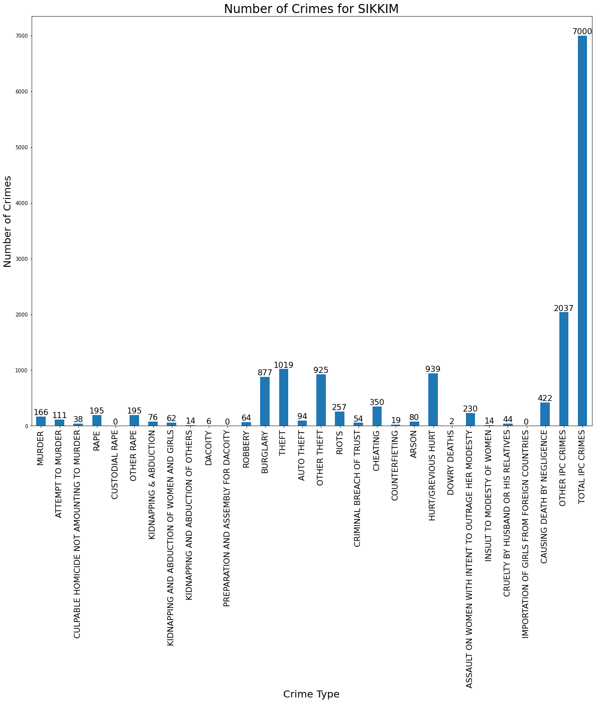

# From Above Graph We Observe That In Sikkim The 'Burglary', 'Theft','Hurt/Grevious Hurt','Other Ipc Crimes', 'Total Ipc Crimes' , , 'Causing Death By Negligence' Are More In This State.

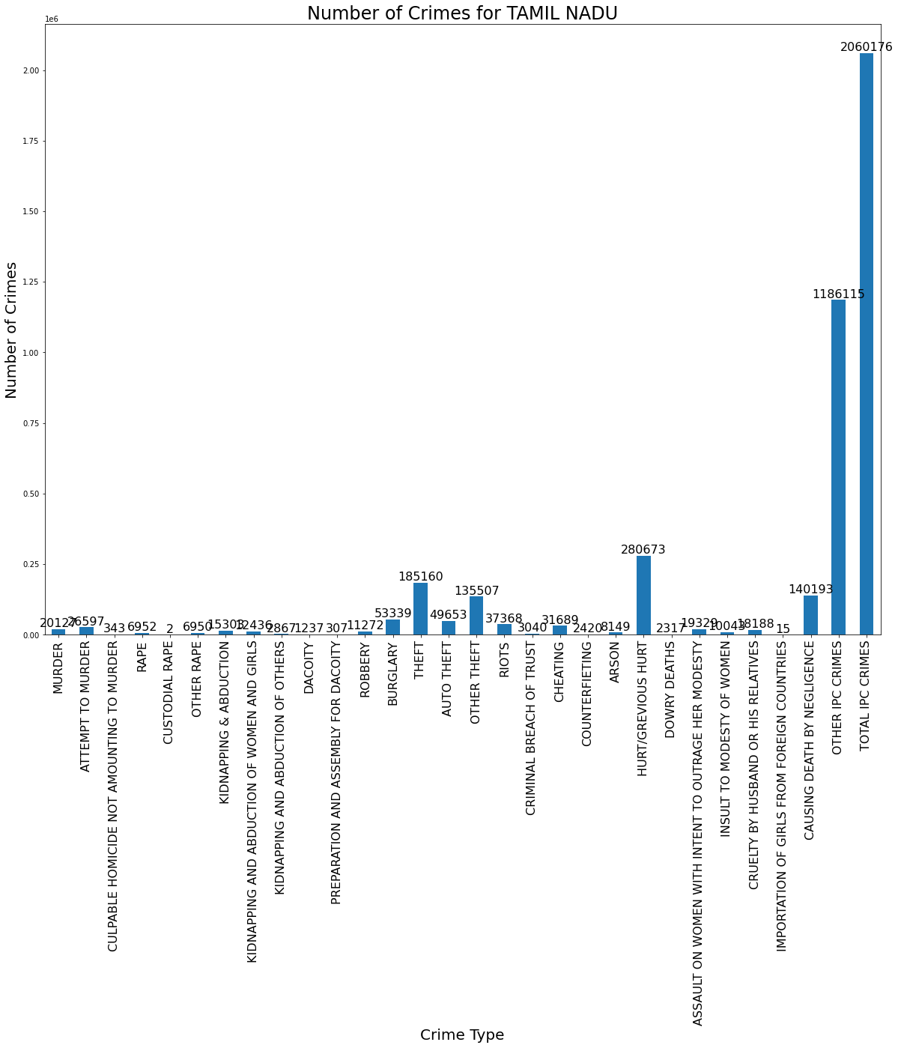

# From Above Graph We Observe That In Tamil Nadu The 'Burglary', 'Theft','Hurt/Grevious Hurt','Other Ipc Crimes', 'Total Ipc Crimes' , 'Causing Death By Negligence' Are More In This State.

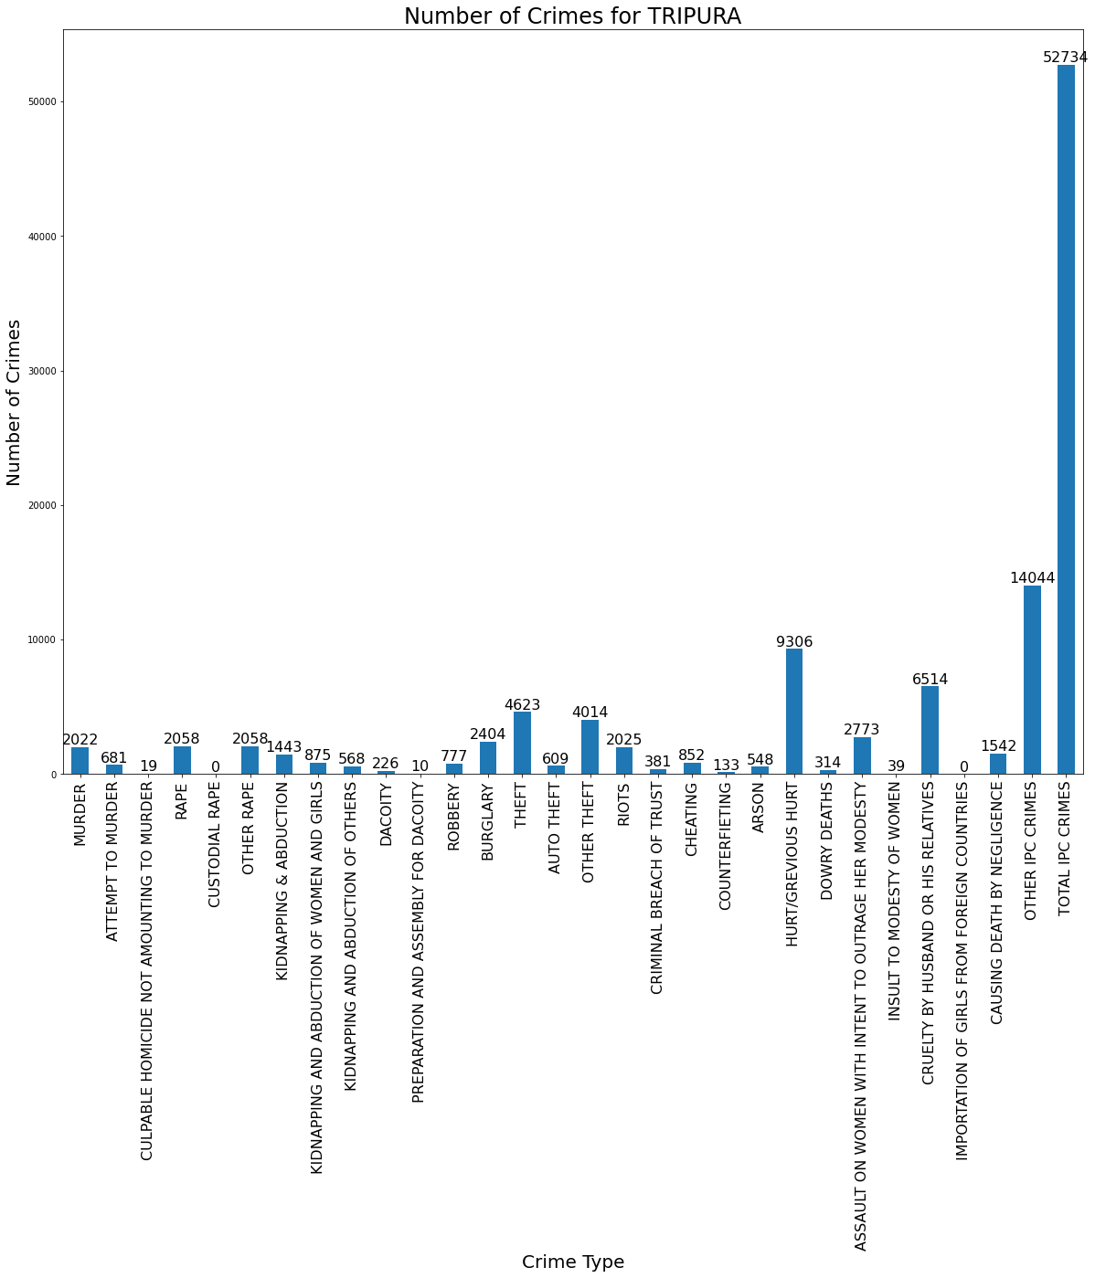

# From Above Graph We Observe That In Tripura The 'Burglary', 'Theft','Hurt/Grevious Hurt','Other Ipc Crimes', 'Total Ipc Crimes' ,Cruelty By Husband Or His Relatives' , 'Causing Death By Negligence' , 'Murder' , 'Rape' Are More In This State.

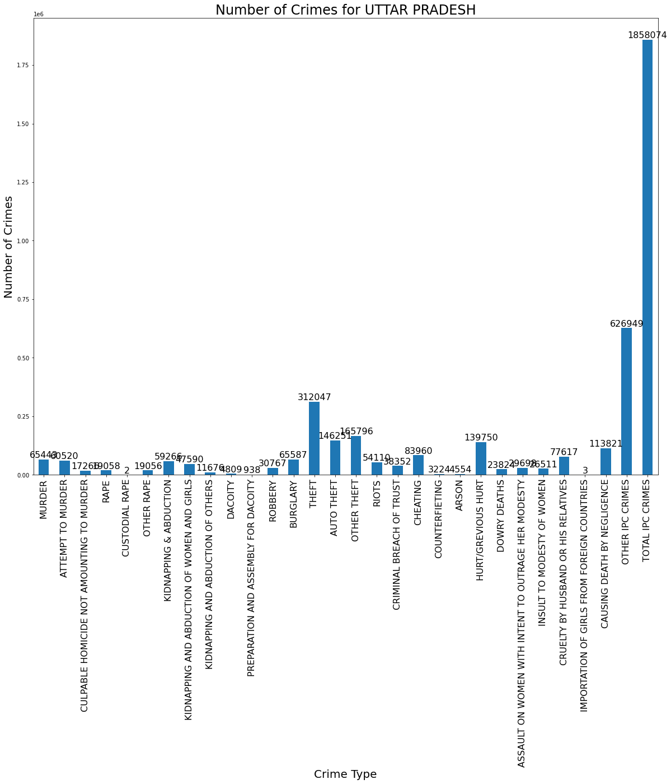

# From Above Graph We Observe That In Uttar Pradesh The 'Burglary', 'Theft','Hurt/Grevious Hurt','Other Ipc Crimes', 'Total Ipc Crimes' ,Cruelty By Husband Or His Relatives' , 'Causing Death By Negligence' ,'Cheating' , 'Murder' , 'Robbery' Are More In This State.

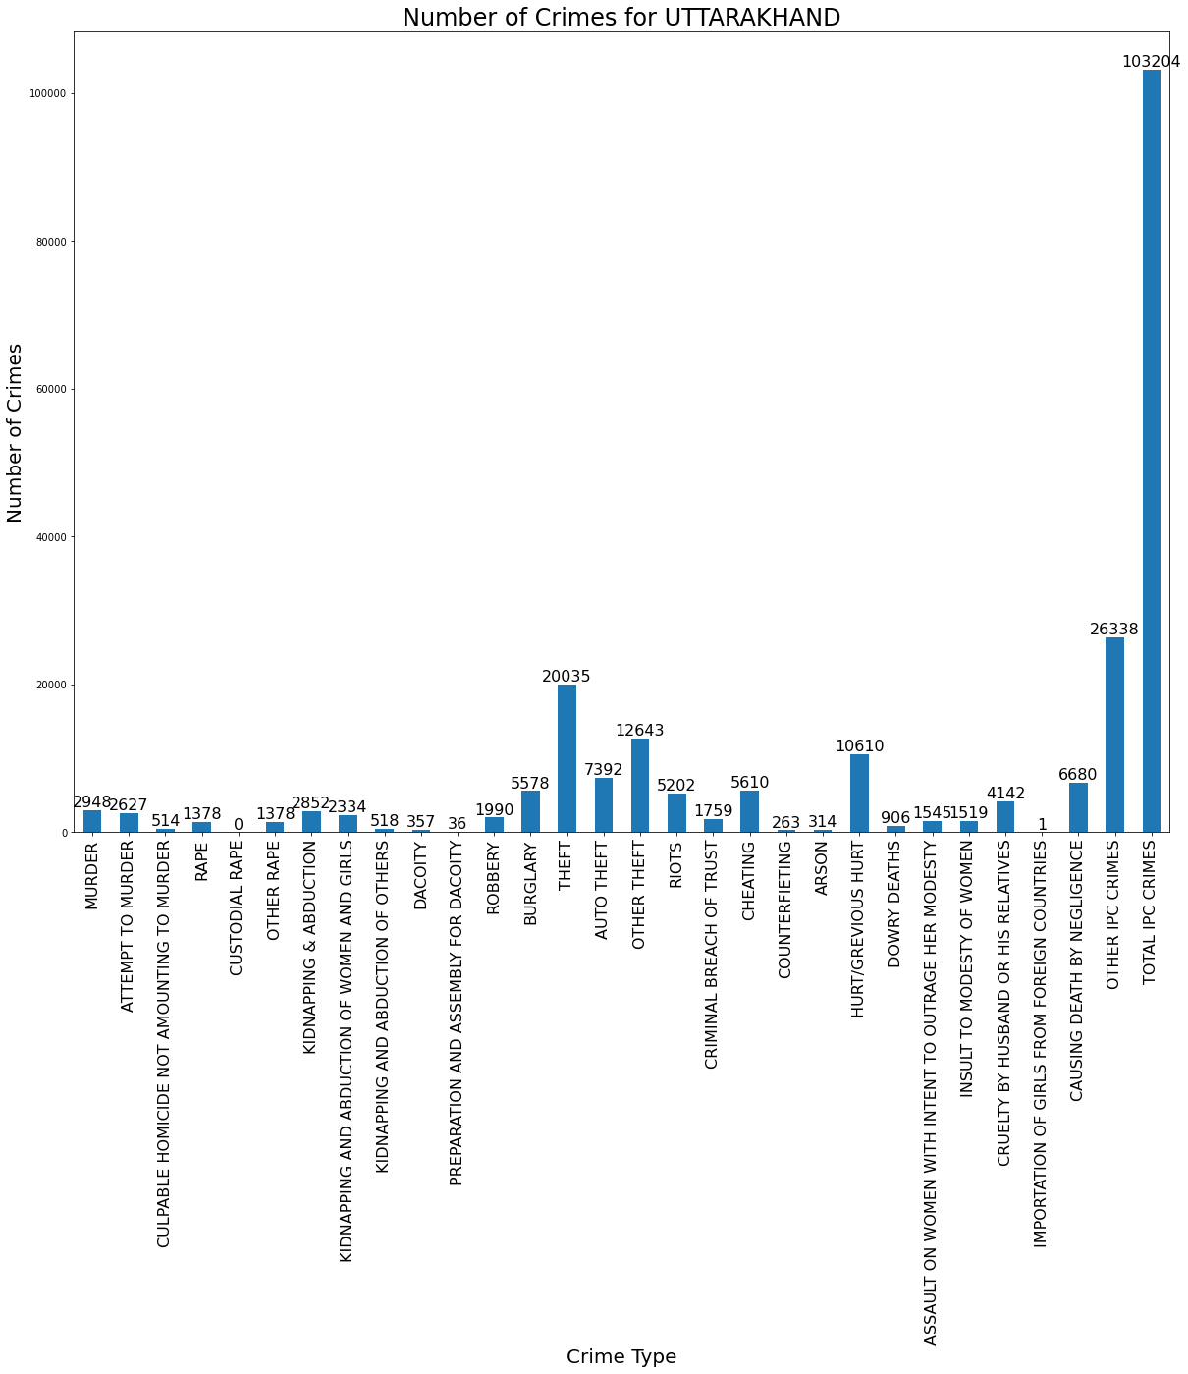

# From Above Graph We Observe That In Uttarakhand The 'Burglary', 'Theft','Hurt/Grevious Hurt','Other Ipc Crimes', 'Total Ipc Crimes' ,Cruelty By Husband Or His Relatives' , 'Causing Death By Negligence' ,'Riots' ,'Cheating' , 'Murder' Are More In This State.

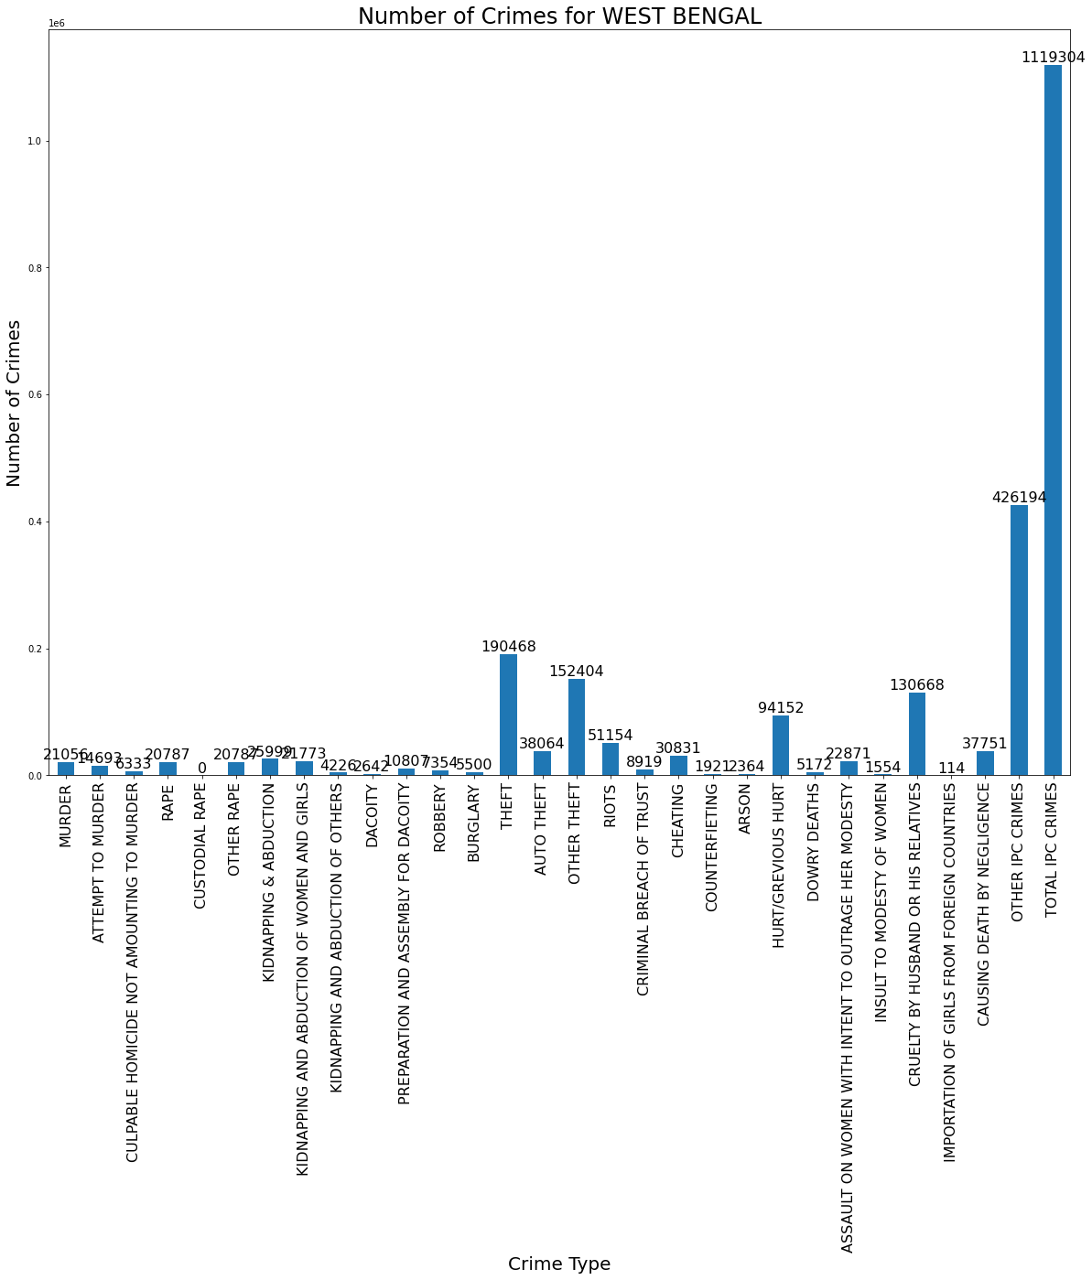

# From Above Graph We Observe That In West Bengal The 'Riots', 'Theft','Hurt/Grevious Hurt','Other Ipc Crimes', 'Total Ipc Crimes' ,Cruelty By Husband Or His Relatives' , 'Causing Death By Negligence','Cheating' Are More In This State.

**2.2 Analysis of the type of crime vs each state vs Literacy rate***.*.

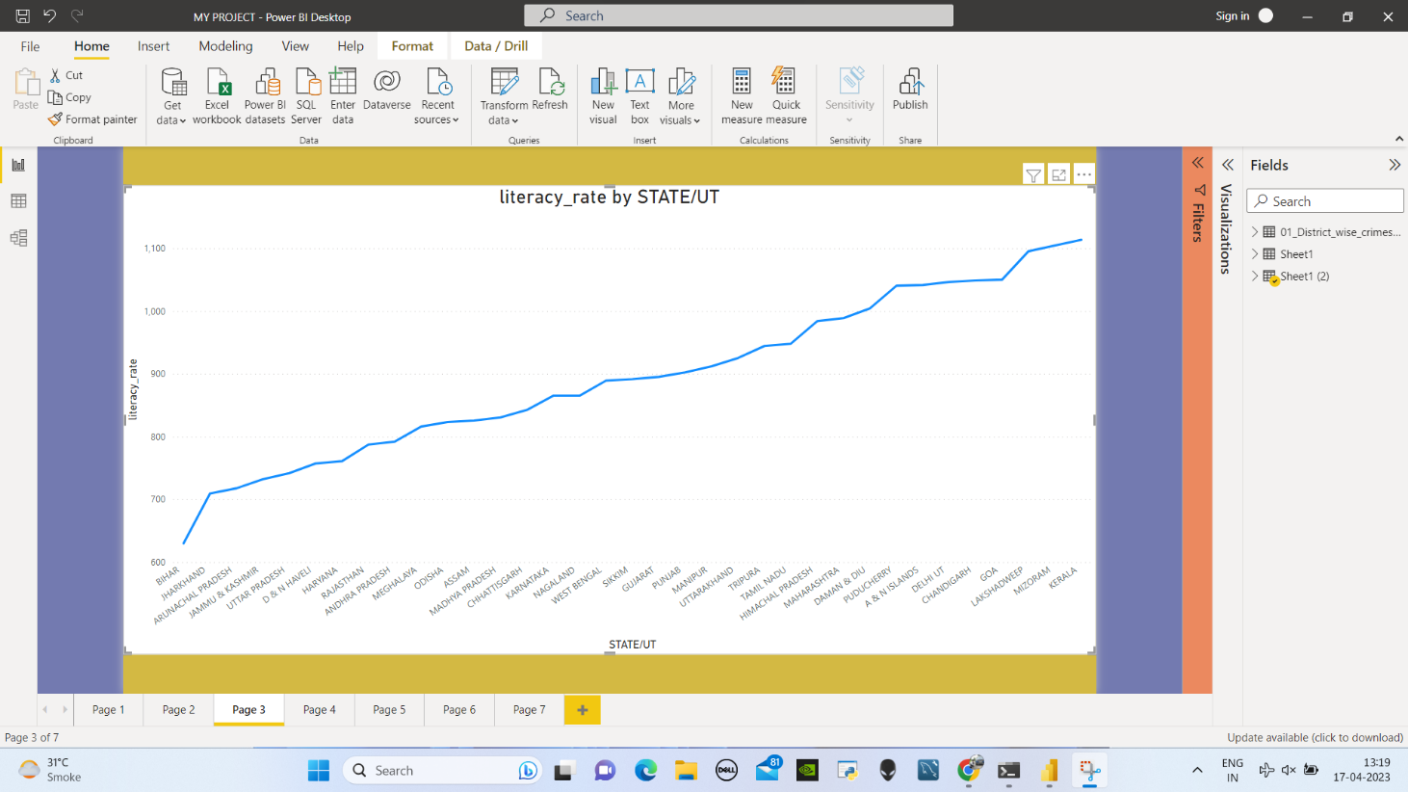

According to the latest census data available, there are significant differences in the literacy rates across various states in India. Bihar, a state in eastern India, has one of the lowest literacy rates in the country, with just over 63% of its population being literate. On the other hand, Kerala, a state in southern India, has consistently topped the charts in terms of literacy rates, with over 96% of its population being literate.

**2.3 Analysis of year-on-year total crime rate.**

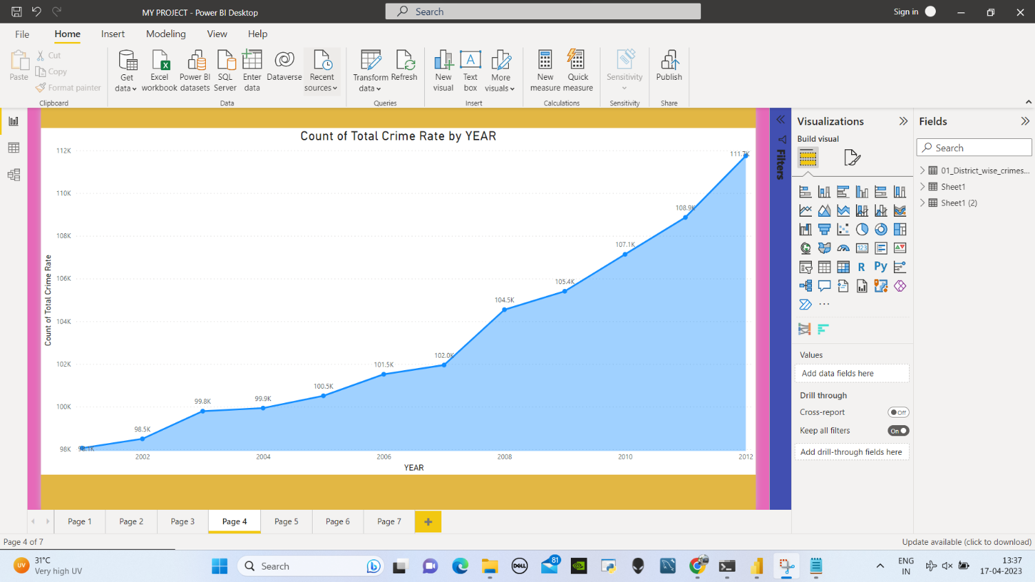

Based on the graph, it is evident that the total crime rate in the year 2002 was relatively low at around 98.5k. However, as time progressed year by year, the total crime rate increased steadily and reached a peak of 111.7k in the year 2012. Furthermore, the total crime rate has continued to increase beyond 2012.

**2.4 Analysis of area vs overall crime**.

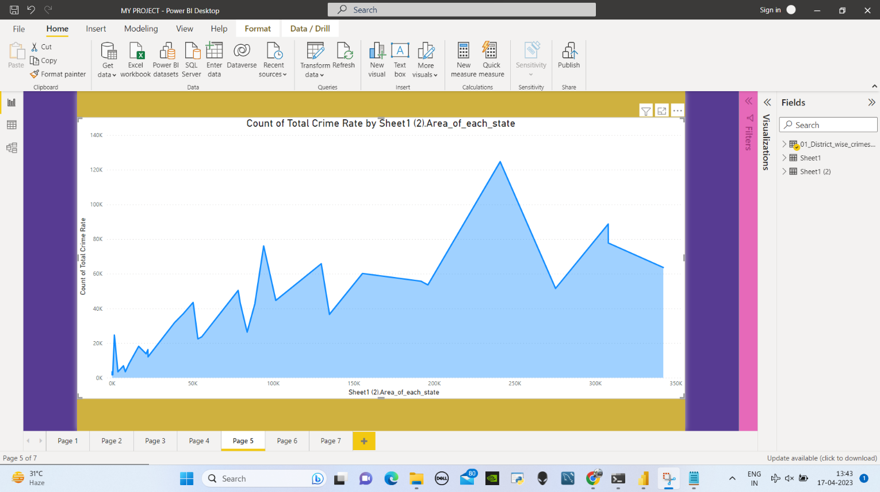

There is a correlation between the area of a state or union territory in India and its crime rate. As the area of a state or union territory increases, the crime rate tends to increase as well. This trend can be observed from an area chart that depicts crime rates over a period of time for different states and union territories.

**2.5 Analysis of population vs overall crime.**

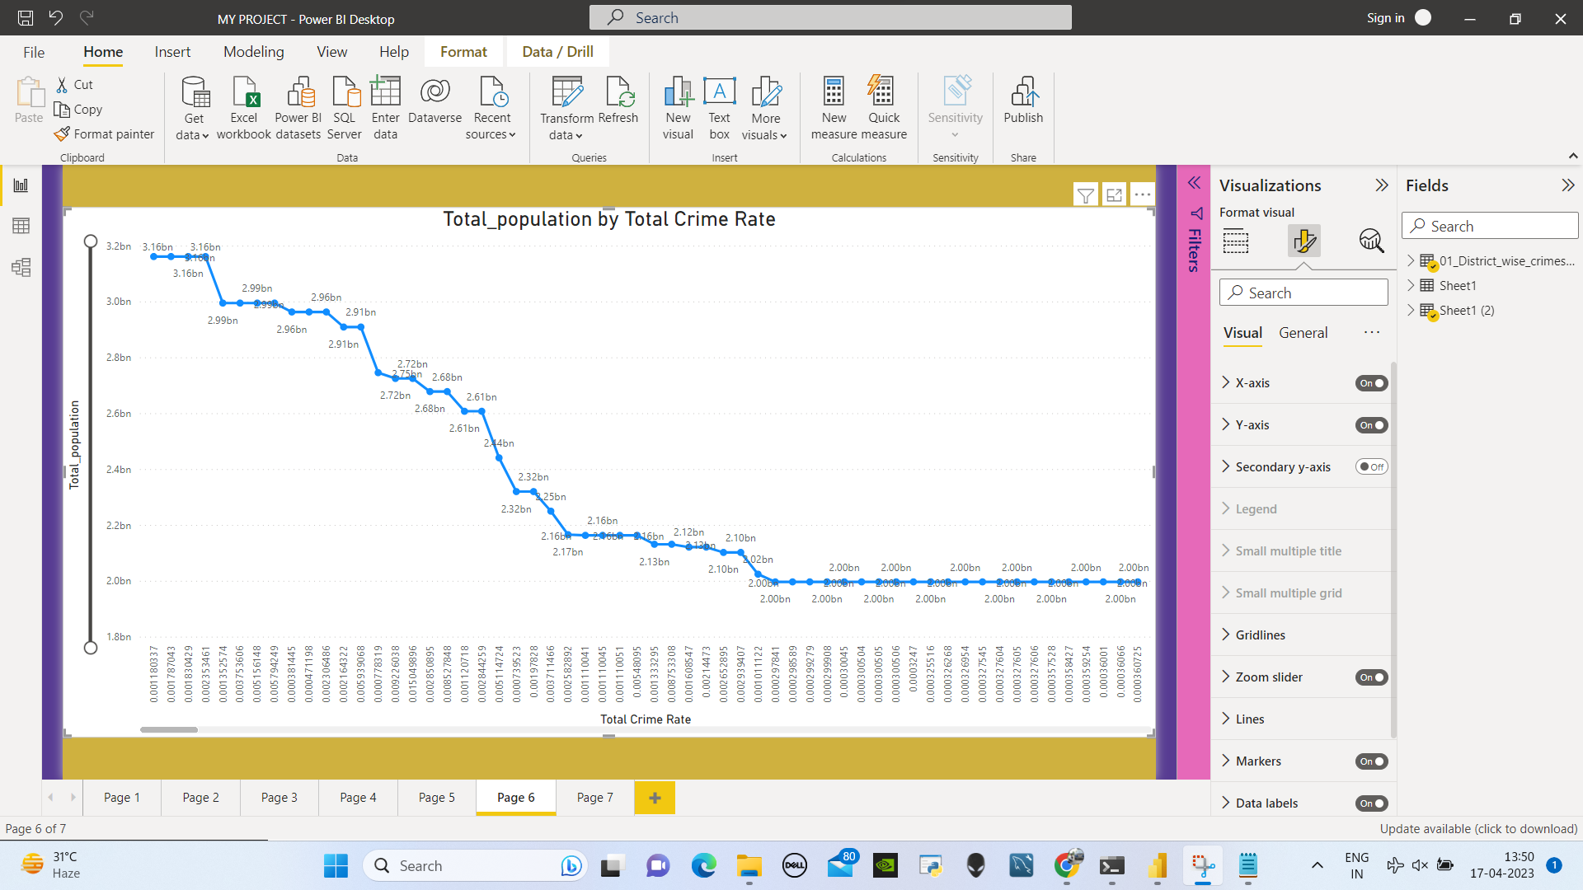

From our observations, we can see that while the population is increasing, the crime rate is also somewhat increasing. While the crime rate may be low or even zero at certain times, it does not remain constant and tends to fluctuate over time. In some periods, the crime rate may be higher than usual, while in other periods it may be lower.

It is important to note that there may be many factors contributing to fluctuations in crime rates, such as changes in law enforcement, shifts in socio-economic conditions, and changes in population demographics. Additionally, the type of crime being measured may have different patterns and trends over time.

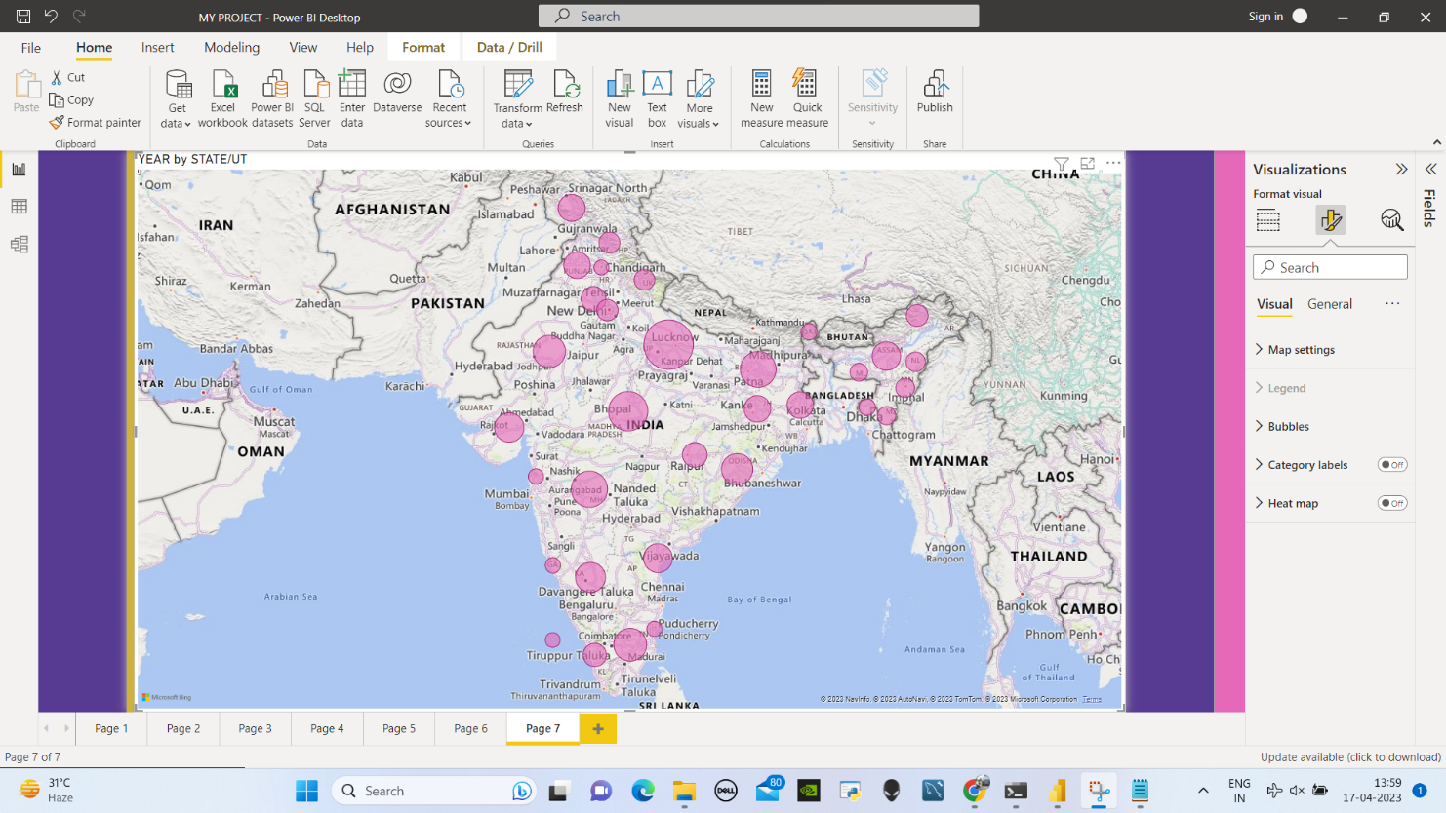

By examining this map and analyzing the size of the bubbles, we can determine which states have the highest and lowest crime rates. The size of the bubbles on the map indicates the relative magnitude of the crime rate, with smaller bubbles indicating a lower crime rate and larger bubbles indicating a higher crime rate.

This information can be useful in understanding the distribution of crime across different states and identifying areas that may require greater attention and resources for crime prevention and control. However, it is important to note that the size of the bubbles may not always reflect the severity or impact of crime in a given area, and other factors such as population density and socioeconomic conditions may also influence crime rates.

Student of DataScience

Student of DataTrained- Saurav

Date - 7-4-2023

Time - 10:52